# Lab 3 – Analytics Rules

## Objectives

This Lab guides you through the Analytics Rule part in Microsoft Sentinel, and shows you how to create different type of rules (Security Detections).

## Prerequisites

This Lab assumes that **you have completed Lab 1**, as the data and the artifacts that we will be using in this Lab need to be deployed on your Microsoft Sentinel instance.

## Task 1: Analytics Rules overview

1. In the browser tab navigate to the Azure Portal [**http://portal.azure.com**](http://portal.azure.com) and search for **Microsoft Sentinel** and click on **Microsoft Sentinel**.

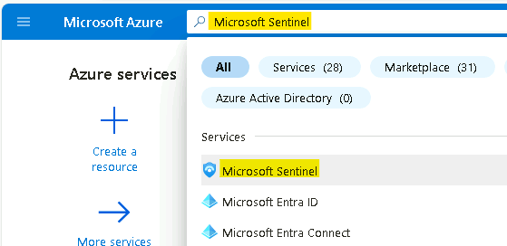

1. Select **MicrosoftSentinelWorkspace**.

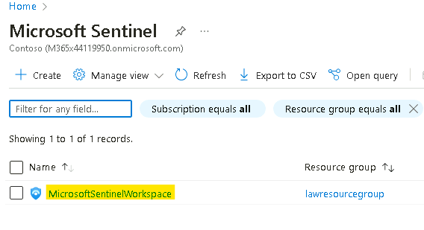

1. On the left menu navigate to **Analytics** and select **Rule template** section

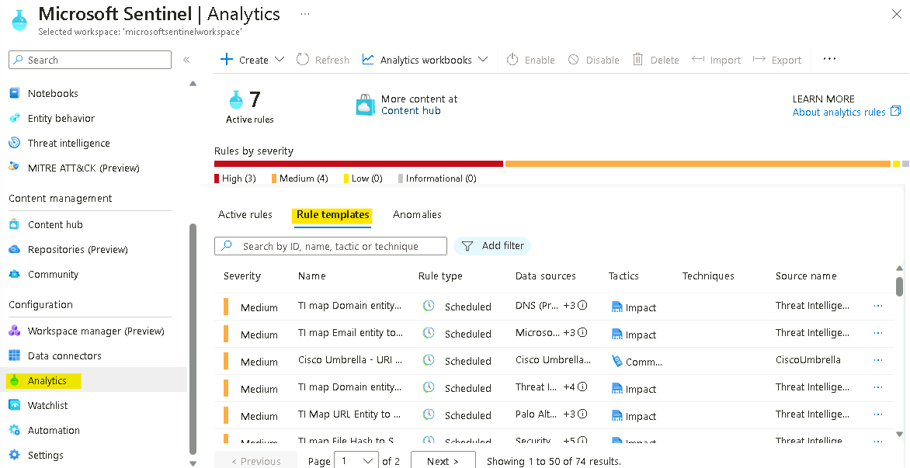

1. Click on Rule templates tab and review the default analytics rules templates, then click on **Add filter** then select **Data Sources**.

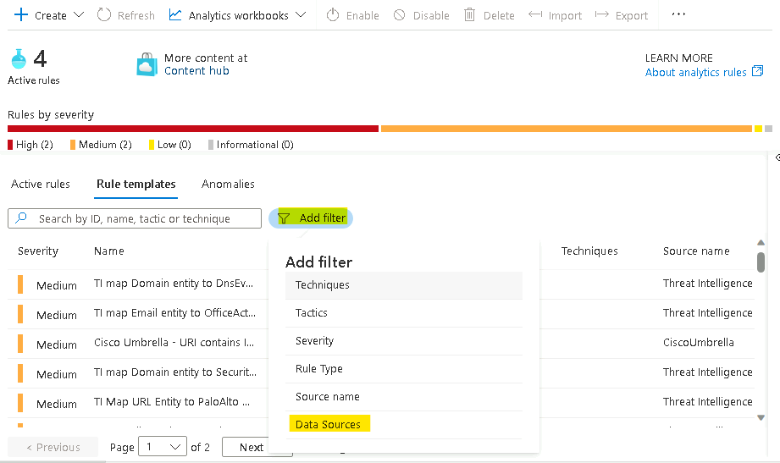

1. Check **Security Events via Legacy Agents**, select **Apply**. Now review all the analytic rules on the above data source.

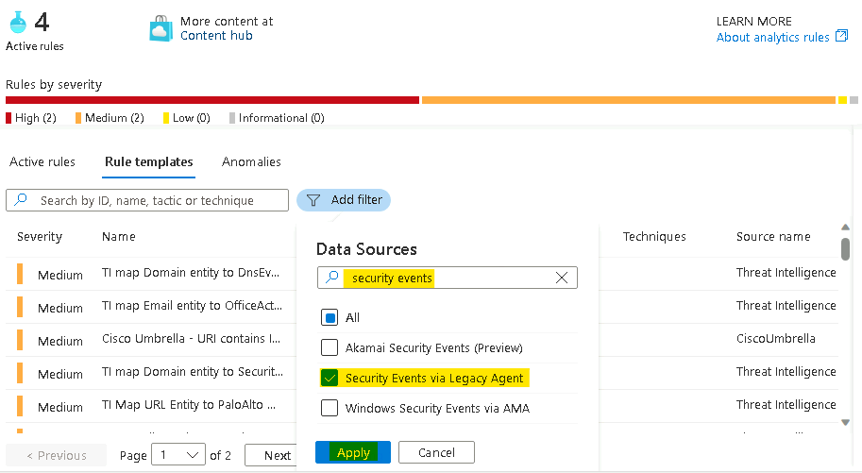

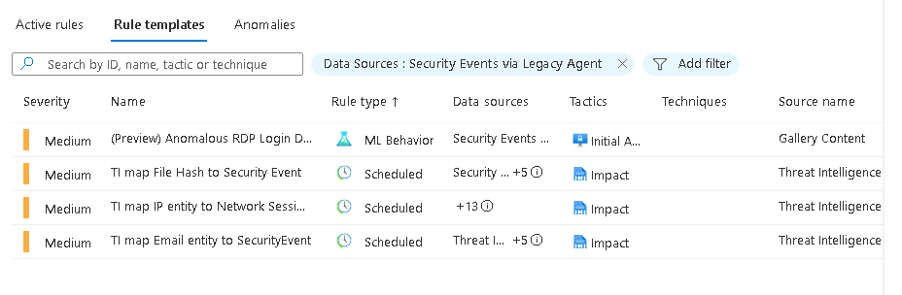

1. In the rule search bar type **Anomalous RDP Login** for the rule name. Select the rule and open the side panel.

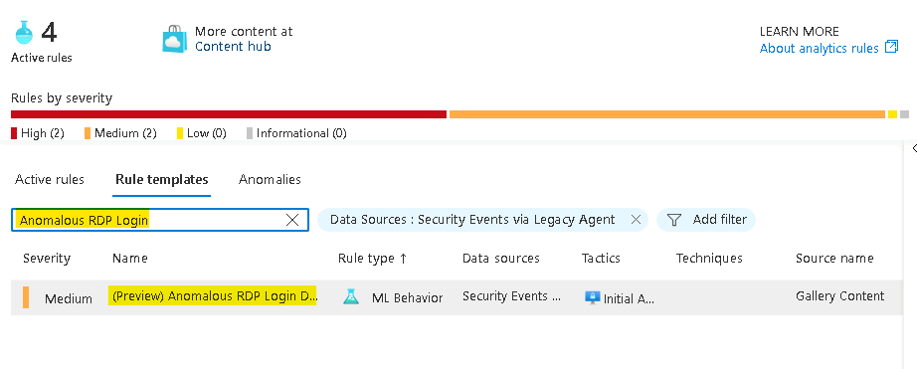

1. To review the rule logic and possible configuration options, in the right lower corner press **Create rule.**

**Note - If the Create rule button does not appear, ensure the panel is enabled from the right side of the screen.**

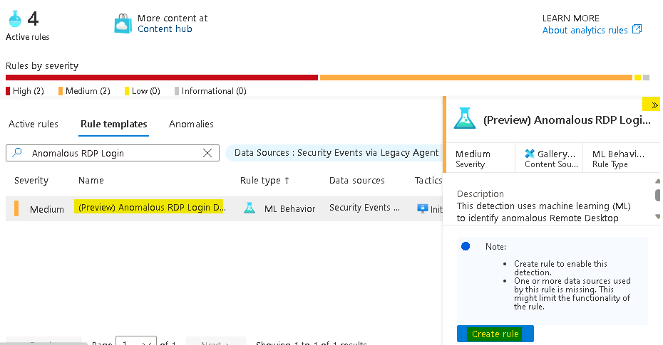

1. Review the rule definition like tactics and severity. Press **Next: Automated response** in the bottom of the page.

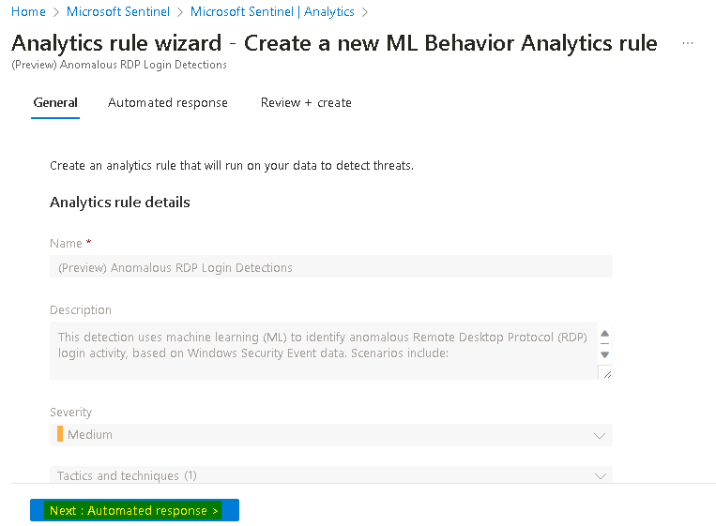

1. On the Automated response tab, click on **+ Add new** to create new Automation rule by referring to the image shown below.

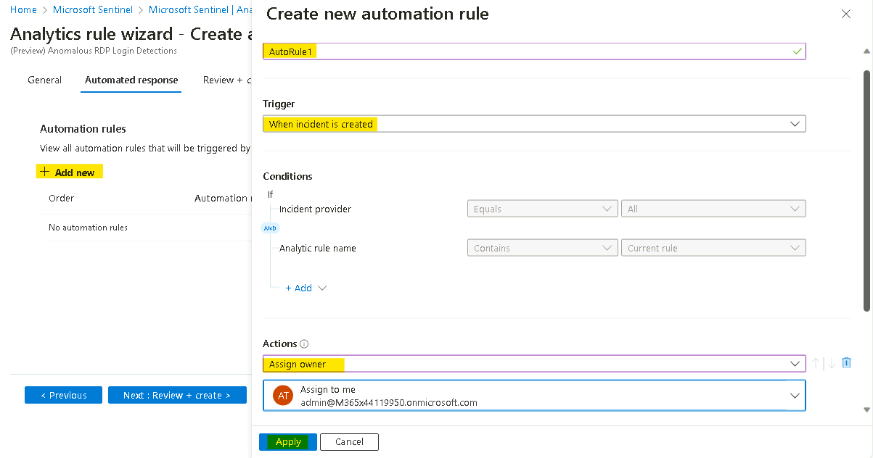

1. After you reviewed the rule configuration options, close this page and navigate back to the main **Microsoft Sentinel Overview** screen. Continue to the next exercise.

## Task 2: Creating Microsoft Sentinel custom analytics rule

Microsoft Sentinel is a cloud-native SIEM and as such, it acts as single pane of glass for alerts and event correlation. For this purpose, and to be able to ingest and surface alerts from Microsoft Security Products, we create a **Microsoft incident creation rule**. In this exercise, we will review this feature and create one example rule with a filtering option to help the analyst deal with alert fatigue.

1. While still on the **Microsoft Sentinel** under the **Analytics** section click on **+Create** and select **Microsoft incident creation rule**.

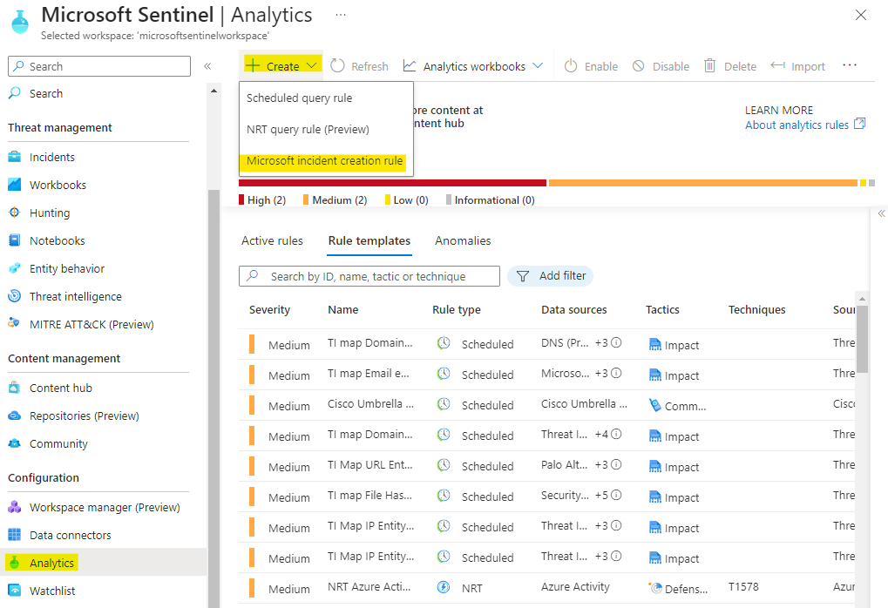

1. In the rule name enter "**Defender for Cloud only medium and high Alerts**".

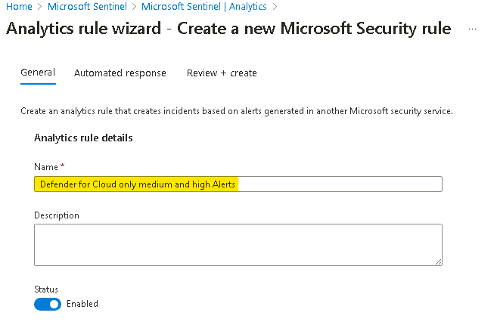

1. In the Microsoft security service dropdown select **Microsoft** **Defender for Cloud**.
2. In the **Filter by severity** select custom and select the checkboxes for **High** and **Medium**.
3. Click on **Next: Automated response**.

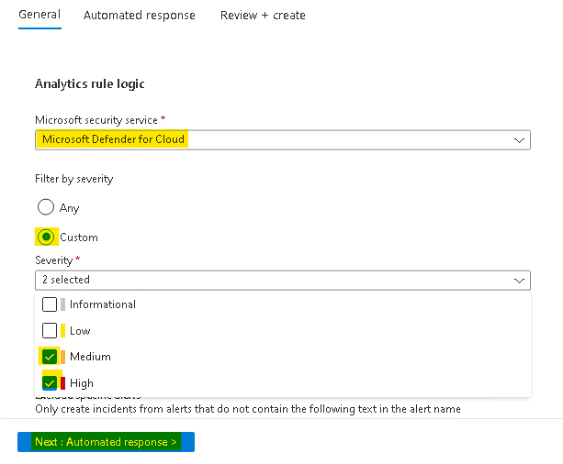

1. In the above **"Automated response"** page you can attach automation rule that can generate automation tasks that can assist your SOC with repetitive tasks, or Security remediation. Click on **Next: Review + create**.

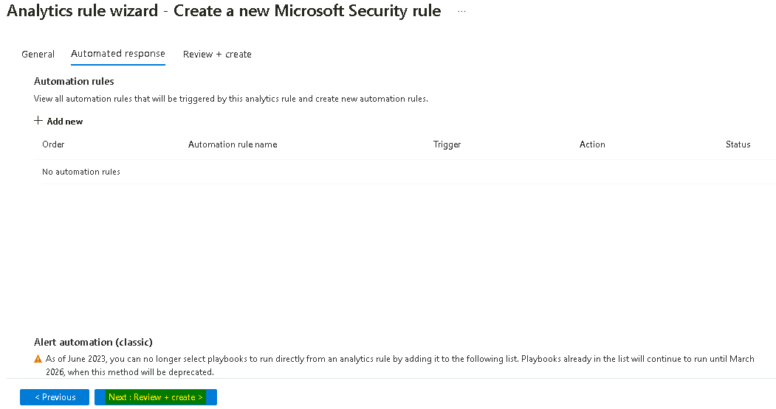

1. On the Review + create page, click on the Save button.

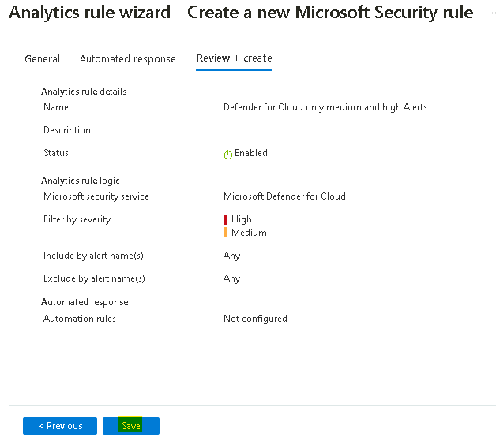

1. Stay on the **Analytics** page and continue to the next **Exercise**.

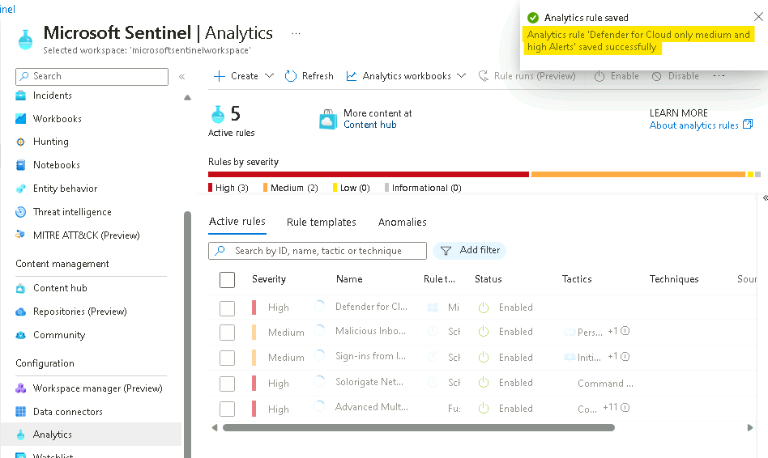

## Task 3: Reviewing Microsoft Sentinel incident tools and capabilities.

Fusion rule is a unique kind of detection rule. With Fusion rule, Microsoft Sentinel can automatically detect multistage attacks by identifying combinations of anomalous behaviours and suspicious activities That are observed at various stages of the kill-chain.

In this exercise, we will learn how to distinguish and review **Fusion rule** in Microsoft Sentinel.

1. In the analytics page on **Rule templates** tab, click **Add filter** and select **Rule Type**

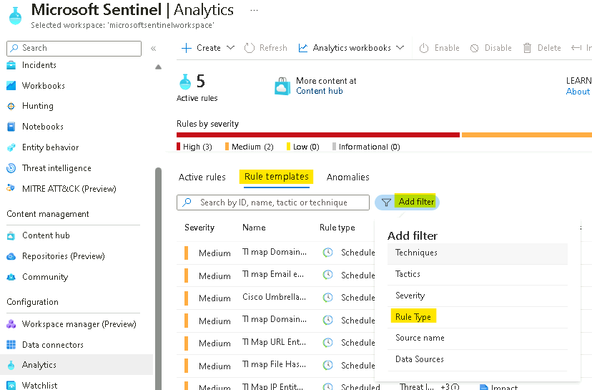

1. Select the check box for **Fusion** and then click on **Apply**.

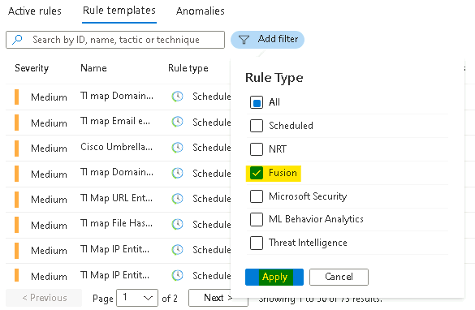

1. In the template screen notice the status as Enabled as this rule template enabled by default.

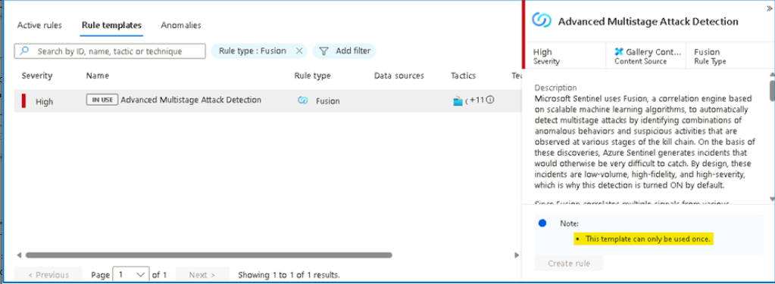

1. From the detail panel, review the details for the **Advanced Multistage Attack Detection** rule . Stay on the same page for next exercise.

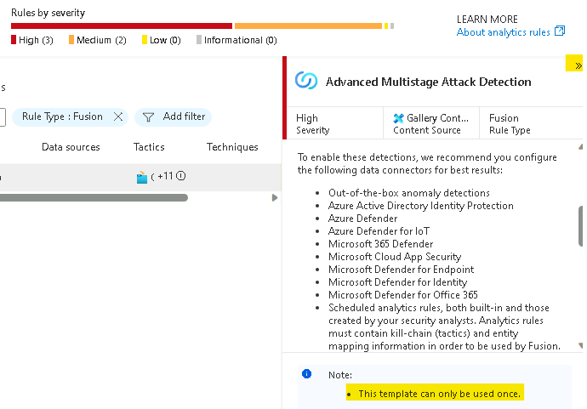

As Fusion rules produce security incidents with high fidelity and simulation can be challenging, we are adding an example of an incident that was created from fusion detection.

In the next example we will see 2 low severity alerts from **Microsoft Entra Identity Protection** and **Microsoft Cloud App Security** that stich together into high severity incidence:

## Task 4: Create Microsoft Sentinel custom analytics rule

1. In the left menu click on the **Logs** close the pop-up and navigate to the search **Canvas**.

**Note: in this lab we are using custom logs that replace the Out-off-the-box tables.**

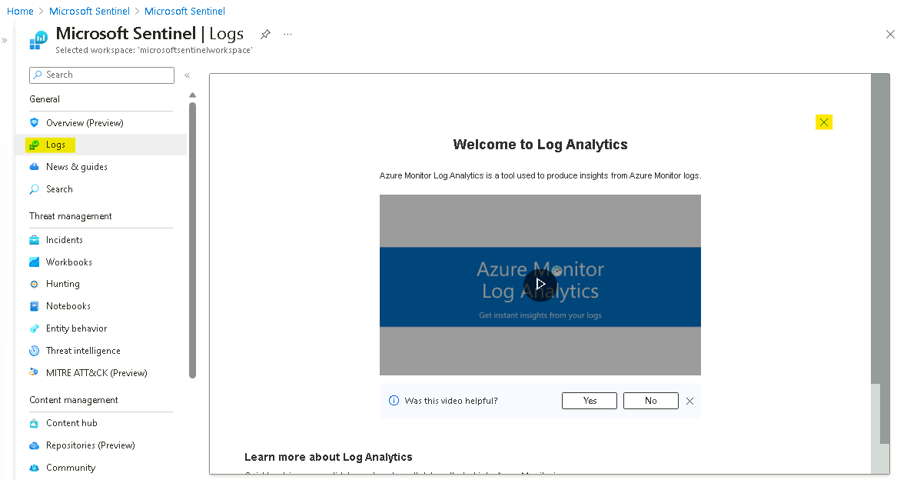

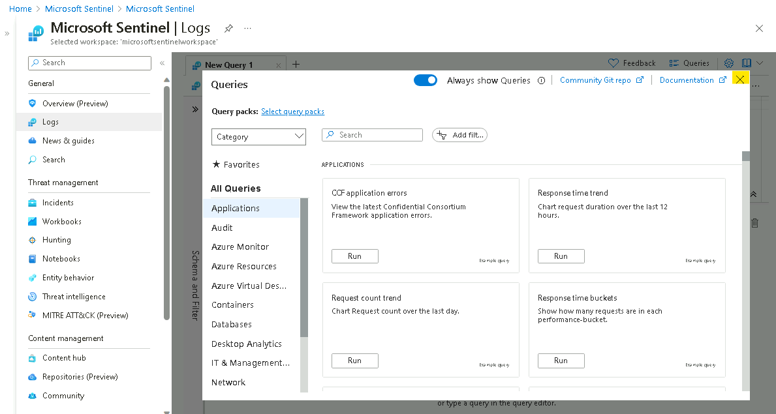

1. To check if this operations are being captured as part of your collection strategy, run the search query below to see the list of activities Microsoft Sentinel captured in the last 24hr

**OfficeActivity_CL | distinct Operation_s**

1. You will be able to see the **New-InboxRule** operation is indeed captured in your logs.

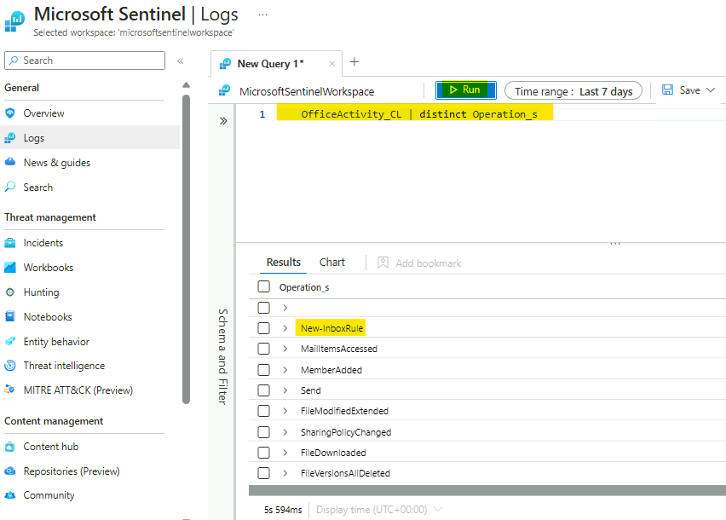

1. Navigate to the **Analytics** from the navigation bar. In the top bar click on **+Create** and select **scheduled query Rule**.

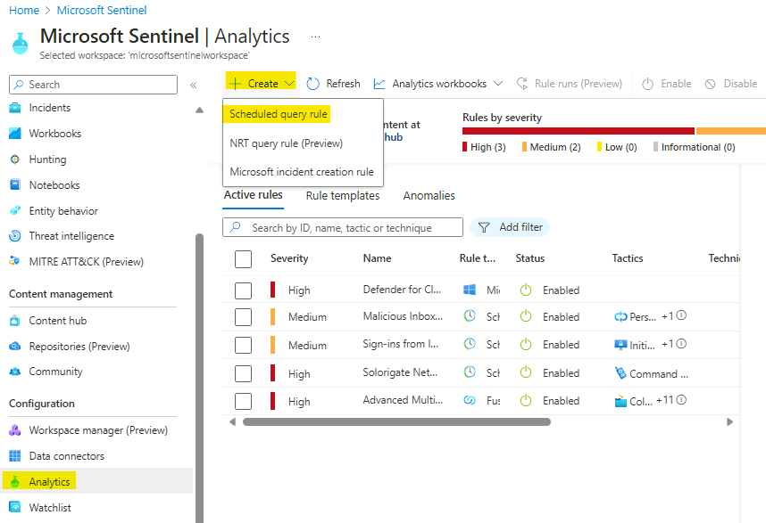

1. On the **Analytics rule wizard - Create a new Scheduled rule** page, provide the below details.
   * In the Name type "**Malicious Inbox Rule - custom**".
   * In the rule **Description** enter **This rule is detecting on delete all traces of phishing email from user mailboxes.**
   * In the **Tactics and techniques** select **Persistence**and**Defence Evasion**.
   * In the rule **Severity** select **medium**.
   * Click **Next: SET rule logic>**.

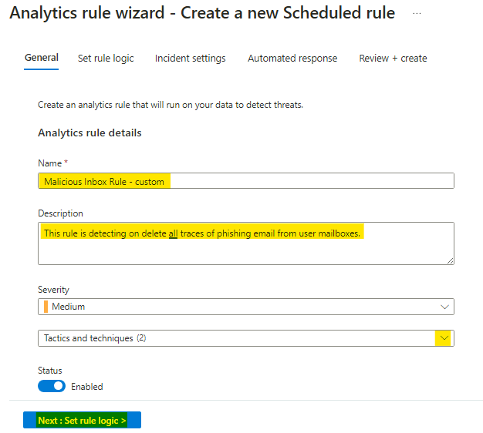

1. In the **Rule logic** page, review and copy the query from the file **Lab3_analytics_rule_query.txt** given in **C:\Labfiles\**
2. We can view the rule creation estimating by pressing **Test with current data** in the right side.

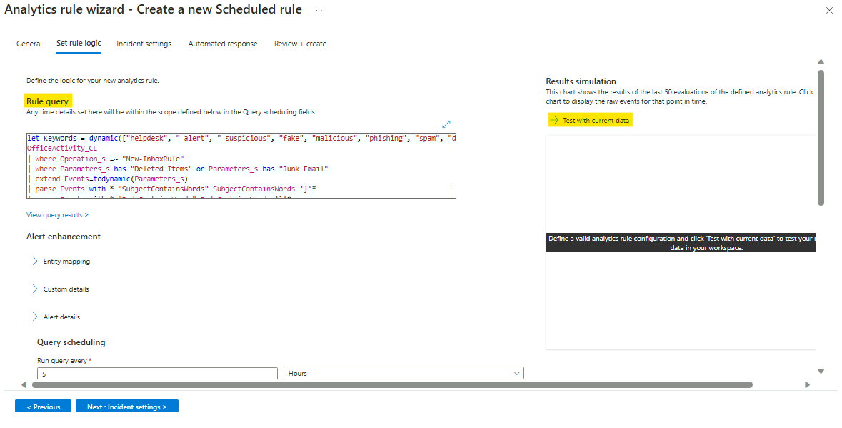

1. You will be able to see the number of hits.

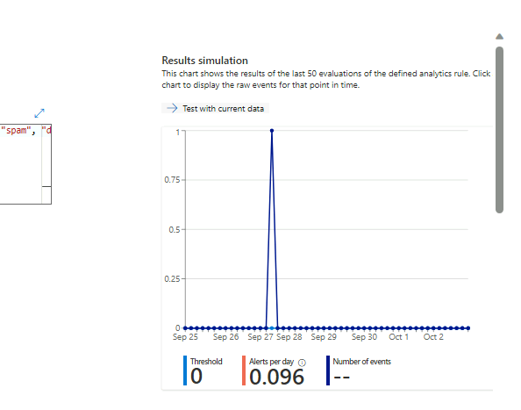

1. Under the **Alert enrichment** expand the **Entity mapping** section that will allow us to map our fields to well-known categories:

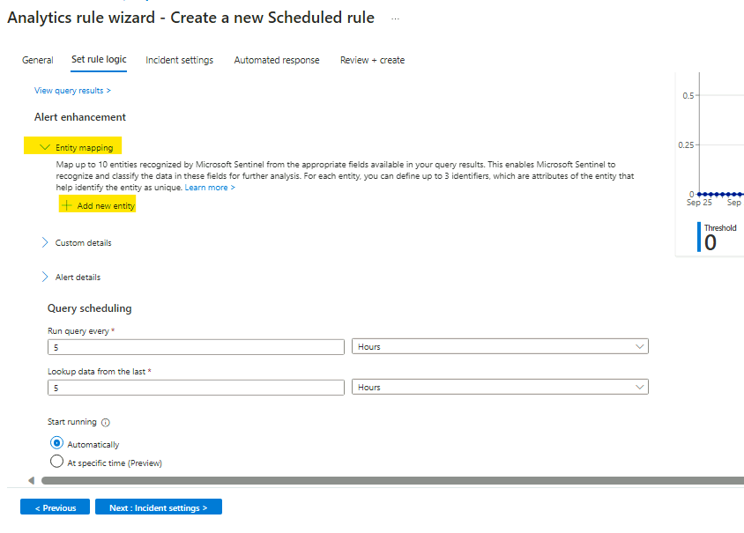

* In the **Entity type** open the supported list of entities and select **Account**.

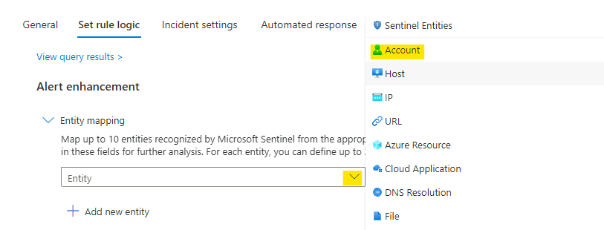

* From the **Identifier** dropdown menu select **FullName** and from **Value** drop down menu select **UserId__s.**

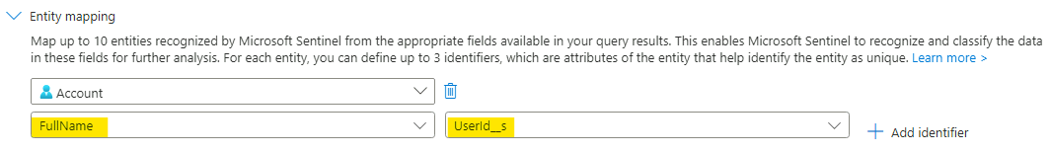

* Click **+ Add new entity** and this time select **Host** entity. From **Identifier** dropdown menu select **FullName** and from **Value** dropdown menu select **OriginatingServer_s**
* Click**+ Add new entity**, select **IP** from **Entity type** dropdown menu, in the **Identifier** select **Address** and for **Value** select **ClientIPAddress** value.

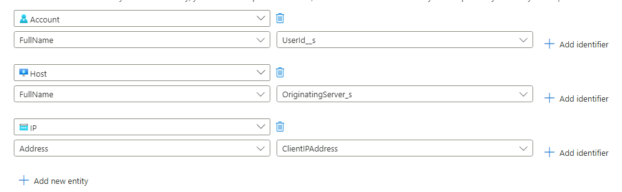

1. Expand the **Alert details** feature and create custom **Alert Name Format.**

* In the **Alert Name Format** enter the dynamic title **"Malicious Inbox Rule, affected user {{UserId__s}}"**

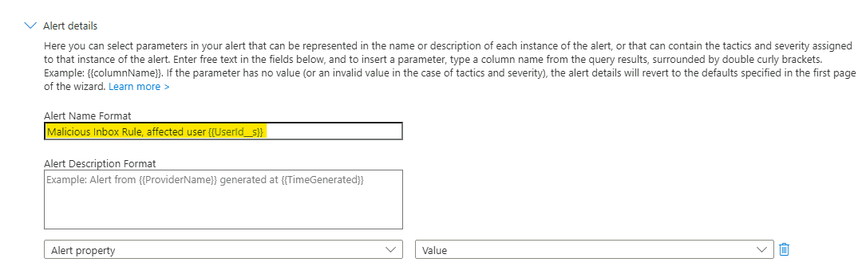

1. Scroll down and in the **Query scheduling** set the **run query every** to **5 minutes** and the **Lookup data to last 12 Hours** (This scheduling might not be ideal for production environment and should be tune). If you deployed the lab more than 12 hours ago, you will need to change the lookback period.

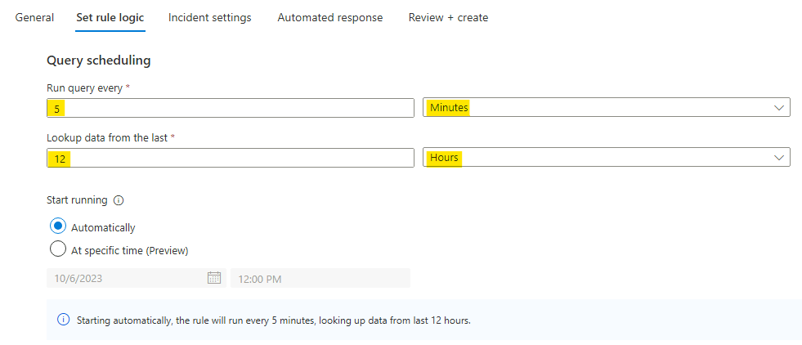

1. In the **Suppression** leave it to **Off.** Click the **Next:Incident settings>.**

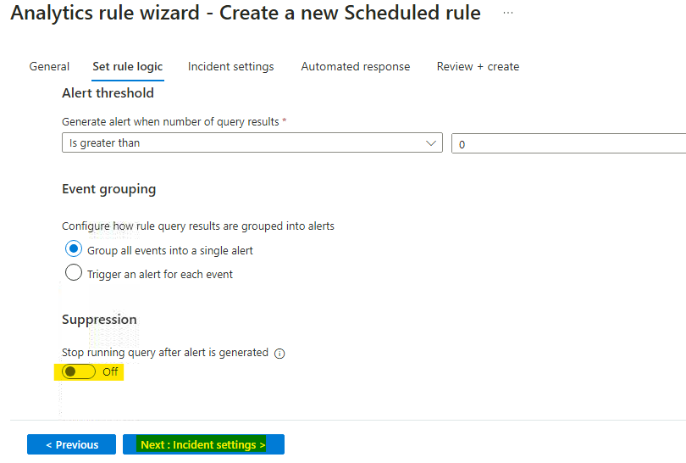

1. To reduce the number of alerts, **implement Alert grouping** feature. To do so, follow the steps below:

* In the **Incident settings** under **Alert grouping** change it to **Enabled**.
* Modify the **Limit the group to alerts created within the selected time frame** to **12 hours**.
* Select the **Grouping alerts into a single incident if the selected entity types and details matches** and select the **Account** and Alert detail as **Name**.

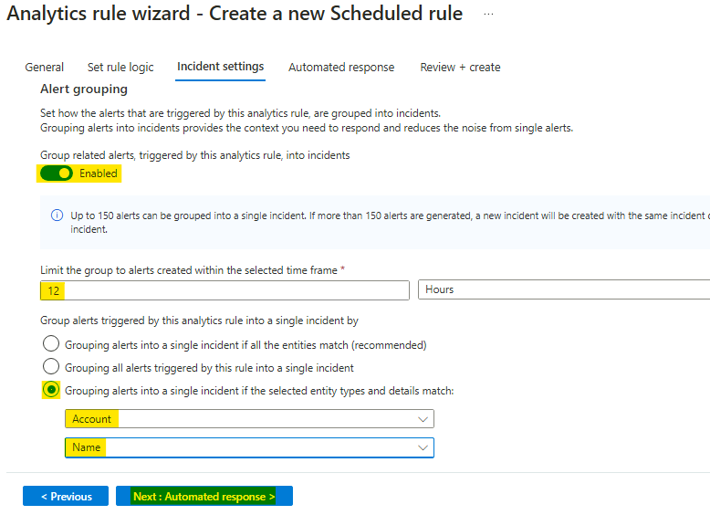

1. Click on **Next: Automated response** and also press **Next:Review** and **Create** this newly analytics rule.

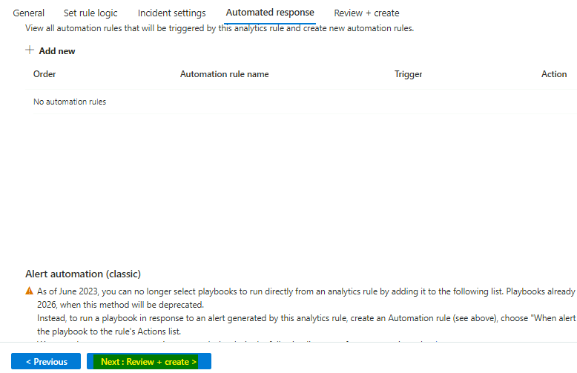

1. On the **Review + create** tab, review the details and then click on **Save** button.

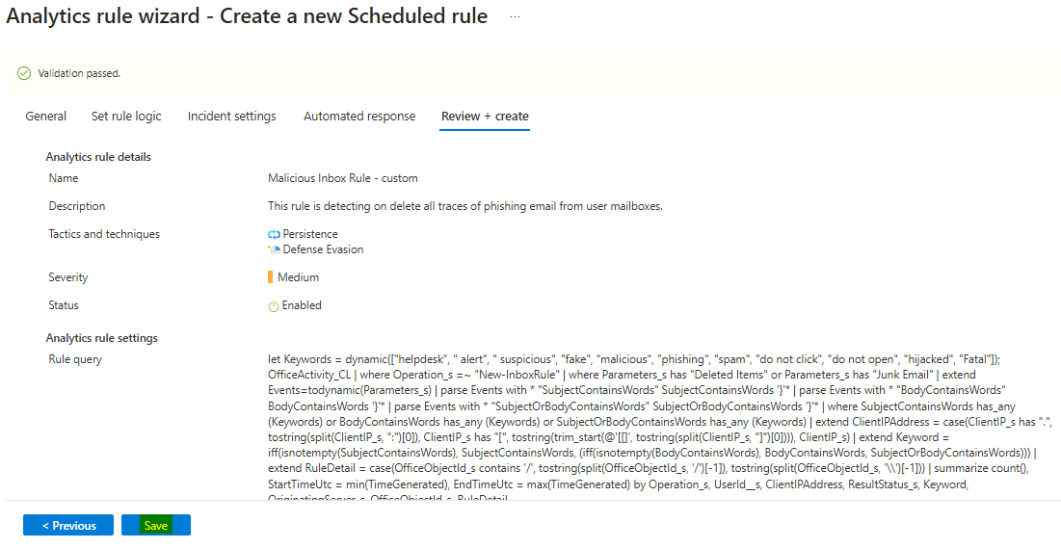

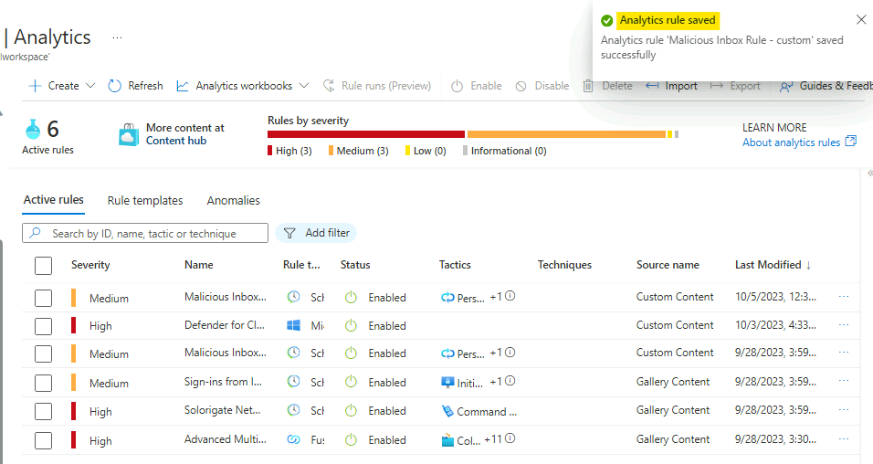

## Task 5: Review resulting security incident

After we created the custom analytics rule that detect us for malicious inbox rule rules. Let's review the incident that was created from this analytics rule.

1. On the main **Microsoft Sentinel** main page, select **incidents** and review the incident page. If you do not see any incidents. Set the time span for **Last 30 days** from the top bar.

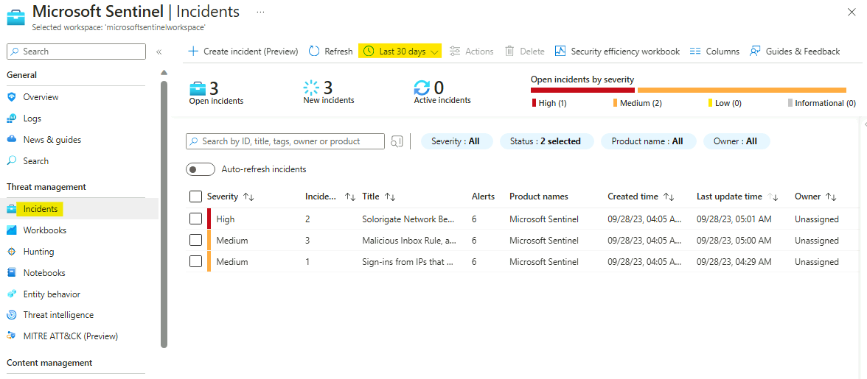

1. Locate a new incident with title **"Malicious Inbox Rule, affected user**[**AdeleV@contoso.OnMicrosoft.com**](mailto:AdeleV@contoso.OnMicrosoft.com)**"** notice that the name adapt and the effected user name added to the incident name.

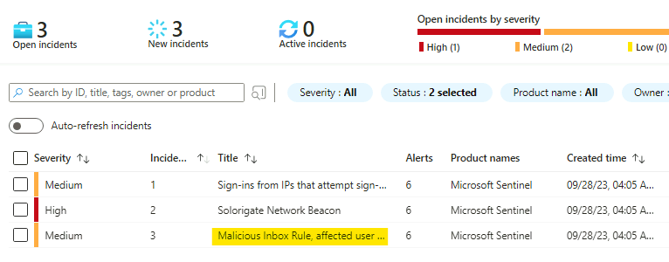

1. In the right pane we can review the incident preview, this view will gave us high level overview on the incident and the entity that related to it.

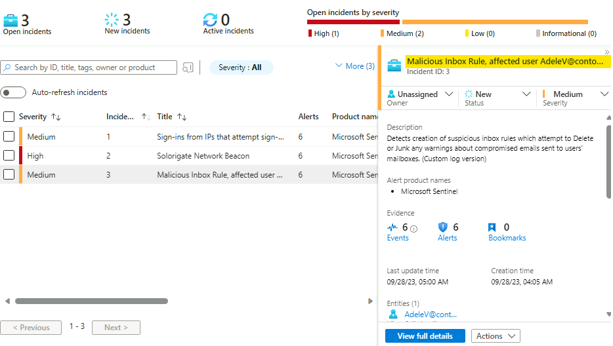

1. Click on the **"view full details".**

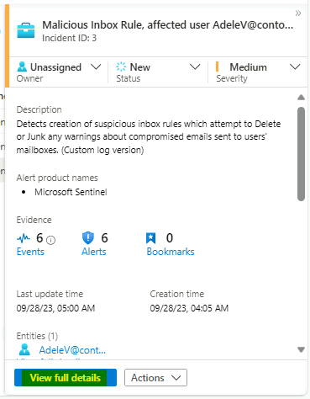

1. In the incident full details page you are able to see **Incident timeline** (effective when you have more than one alert in a given incident).

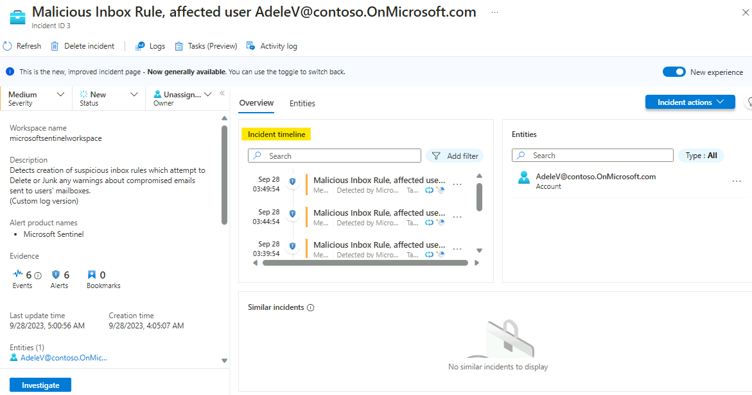

1. Click on the Entities tab to review the names of the Entities associated with the incident.

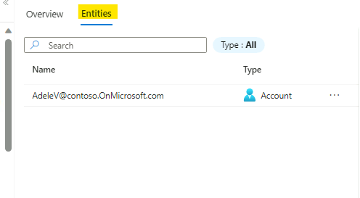

1. Click on the entity **"**[**AdeleV@contoso.OnMicrosoft.com**](mailto:AdeleV@contoso.OnMicrosoft.com)**"** and then click on **View full details** button.

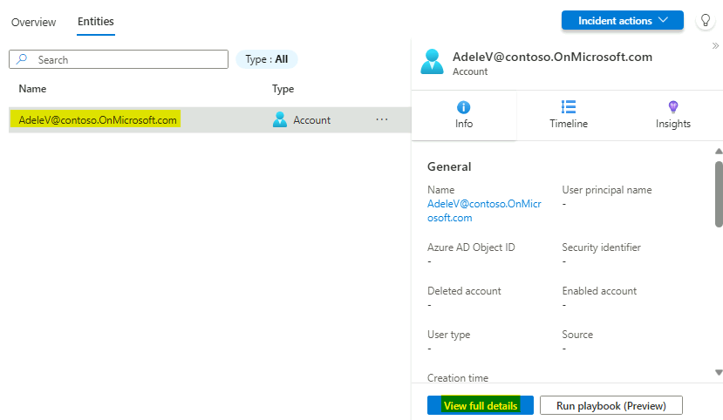

1. This action will navigate us to the user entity page, this page will give us holistic view on the user entity, with all its activity and related alerts. Ensure to select the time to be more than **Last 14 Days**.

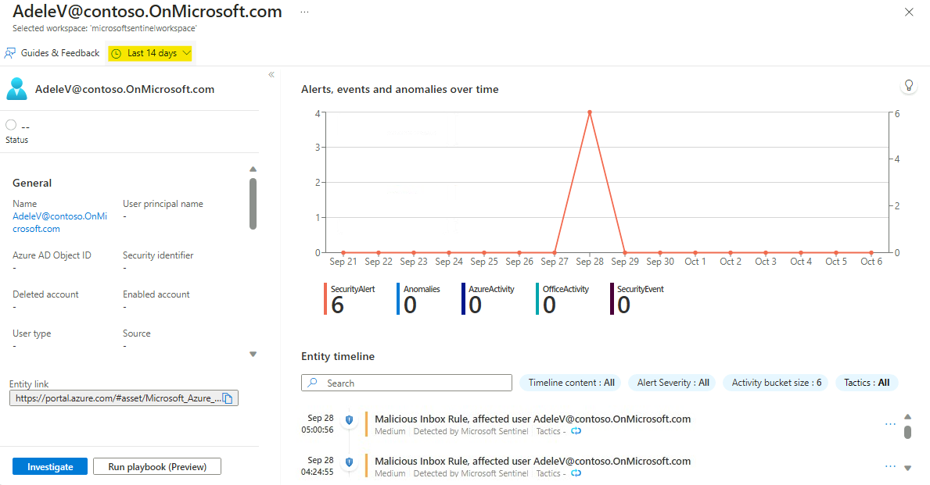

## Task 6 - Handling Incident "Sign-ins from IPs that attempt sign-ins to disabled accounts."

1. On the Azure Portal [**http://portal.azure.com**](urn:gd:lg:a:send-vm-keys), search for [**Microsoft Sentinel**](urn:gd:lg:a:send-vm-keys), then click on **Microsoft Sentinel**.

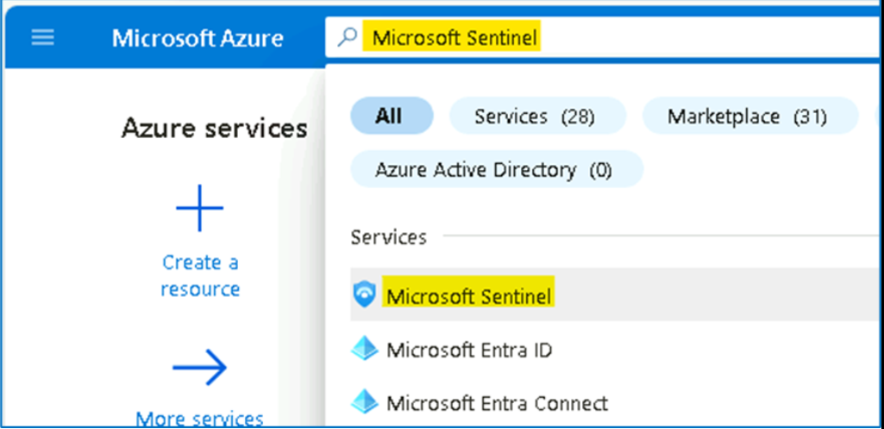

1. Select **SwrkXXXXXXX**.

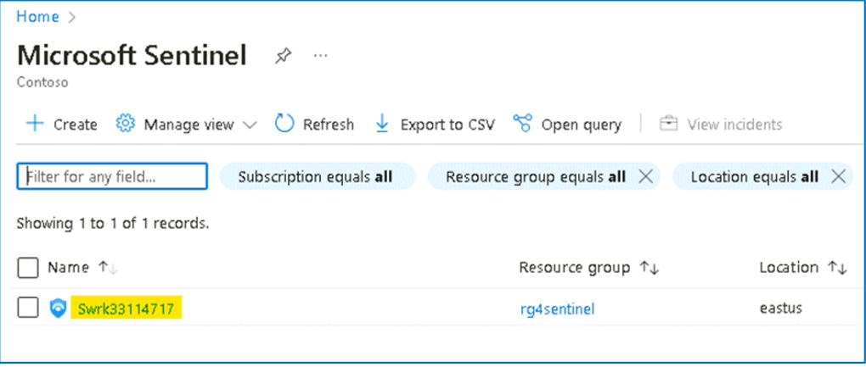

1. On the left menu navigate to Incident page and select the **Sign-ins from IPs that attempt sign-ins to disabled accounts** incident and on the right pane you can see the incident preview with the high level information about the incident.

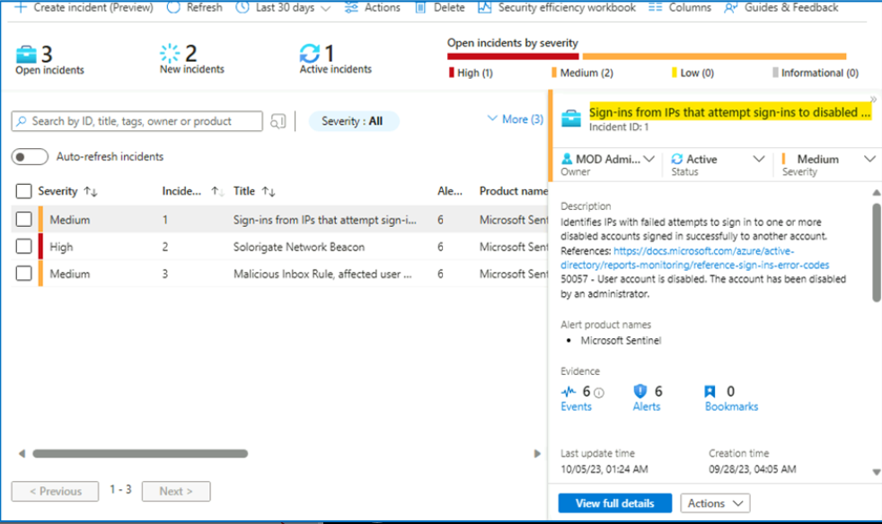

1. Click on the **View full details** button.

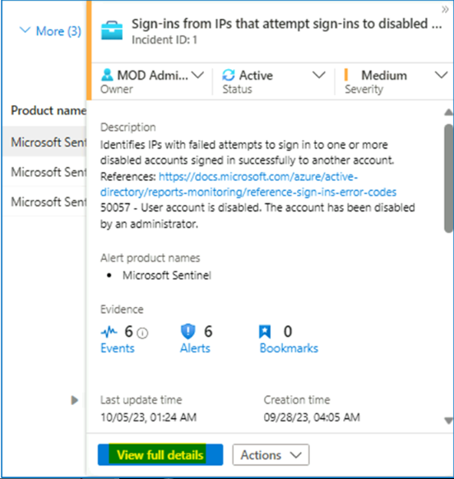

1. On the **Incident** page, select the number of **Alerts**.

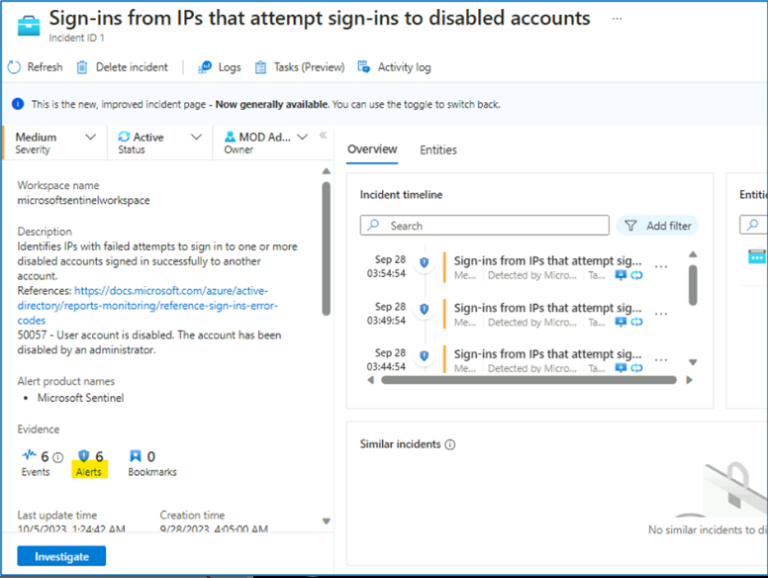

1. You can see the raw logs showing all the events as the result of the query.

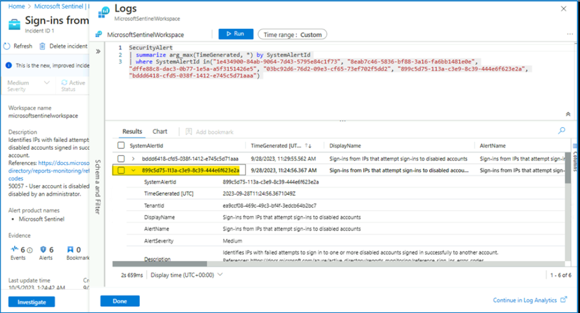

1. In raw log search, expand the **ExtendedProperties**, these properties will help us to decide if this incident is correlated to other events.

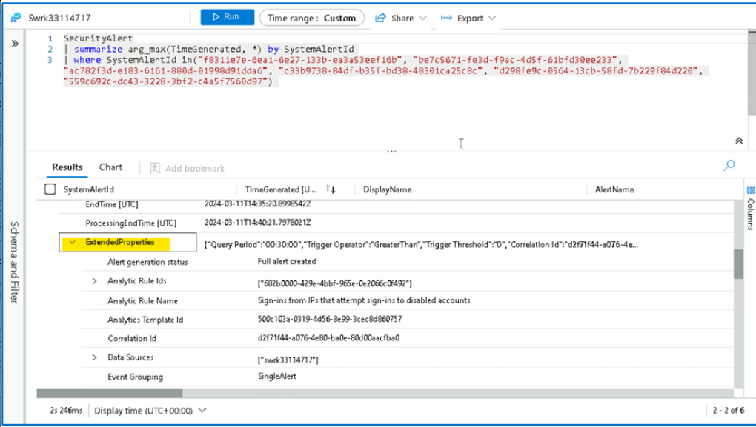

1. Navigate back to the Incident page by clicking **Done**.

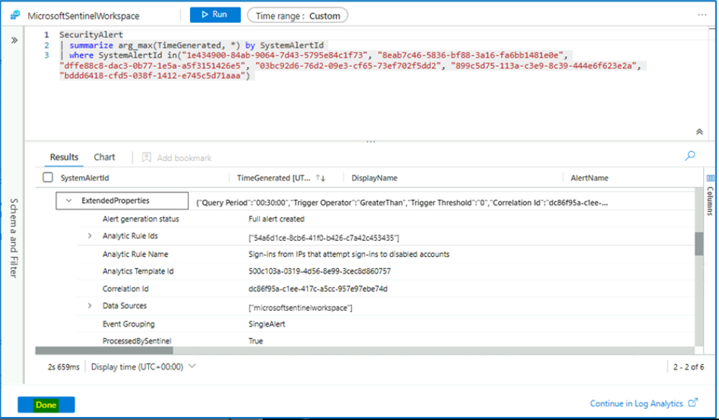

1. In the **Overview** tab, under **Incident Timeline**, select **3 dots** near the latest alert and select **Run Playbook**.

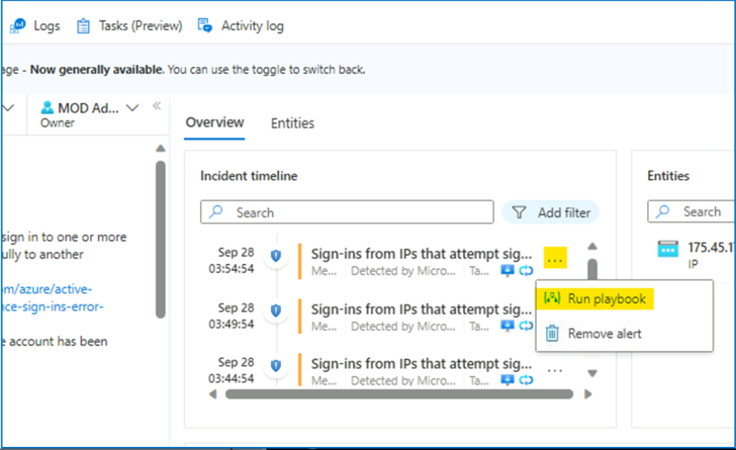

1. Click on **Run** button for the playbook **Get-GeoFromIpAndTagIncident**.

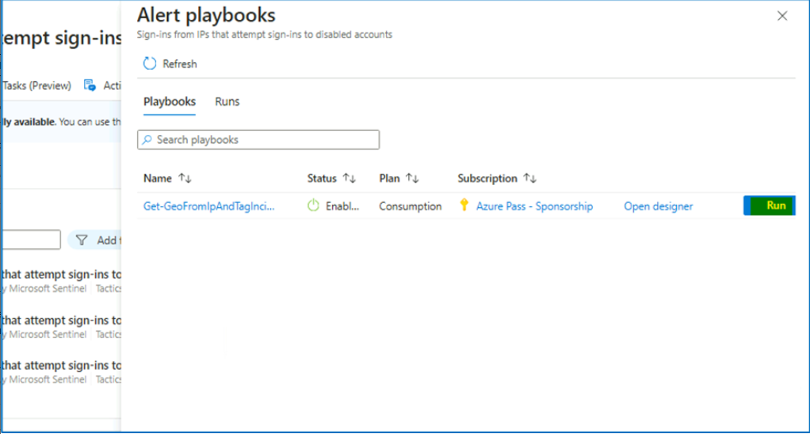

1. If the playbook is configured correctly, it should finish in a couple of seconds and you should be able to see the notification of a successful run.

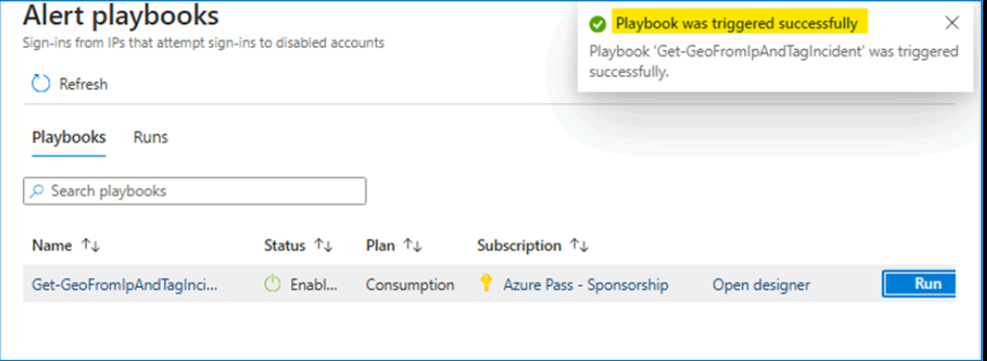

1. You can also navigate to **Run** tab to check if the **Playbook** ran successfully.

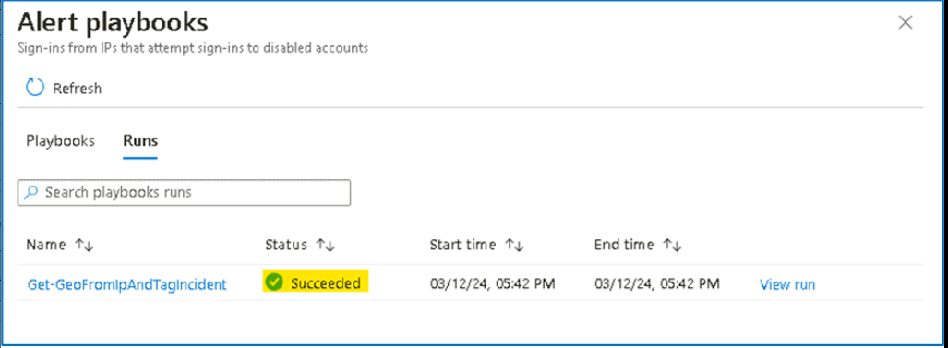

1. Close the dialogue box and navigate back to the main **Incident** page.

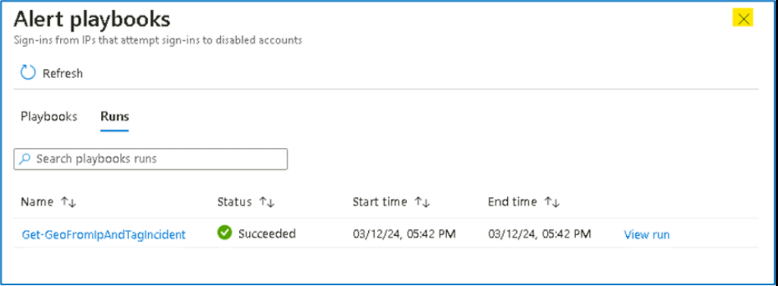

1. Select **Refresh** and now you will notice that new tags are added to the incident.

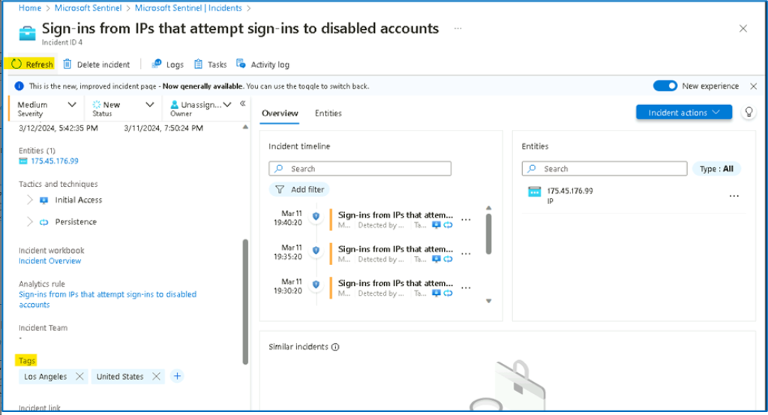

1. Note down the **IP address** under **Entities** into a notepad file. It will be used in the further steps of the lab.

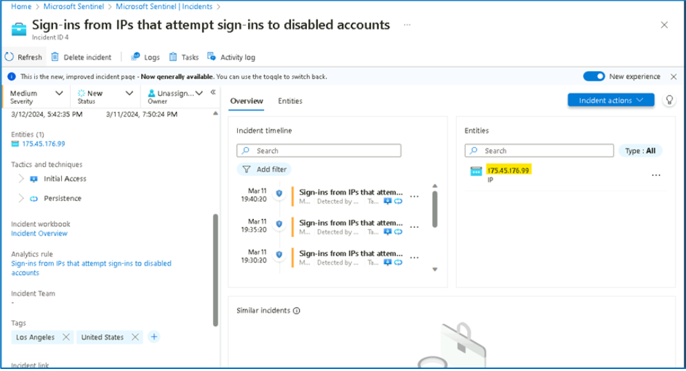

1. Go to **Azure Portal Home page** by selecting Home from the top left corner of the page.

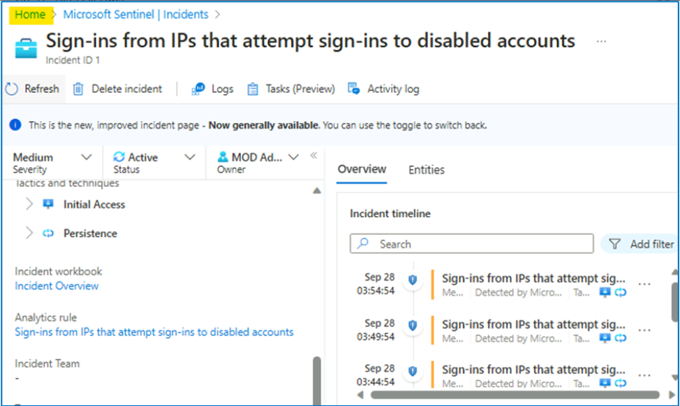

1. Click on Resource groups and then select the **RG4Sentinel** Resource Group.

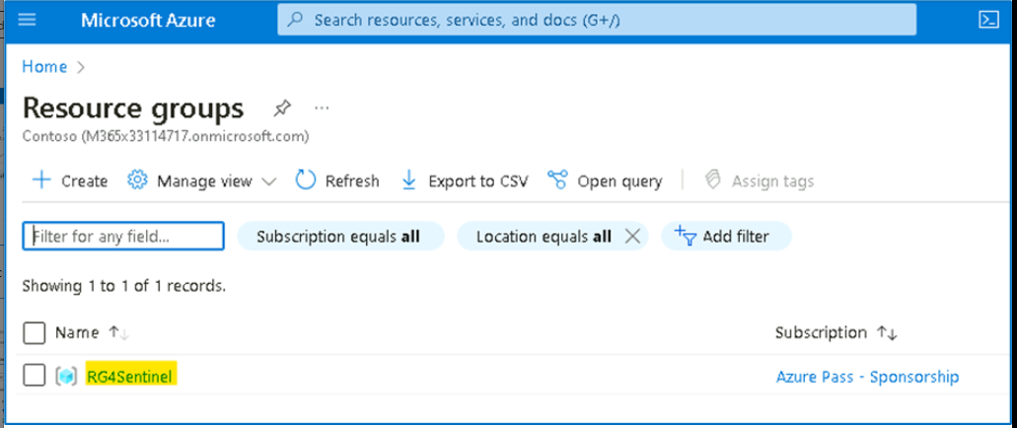

1. Locate the Logic app named **Get-GeoFromIpAndTagIncident**.

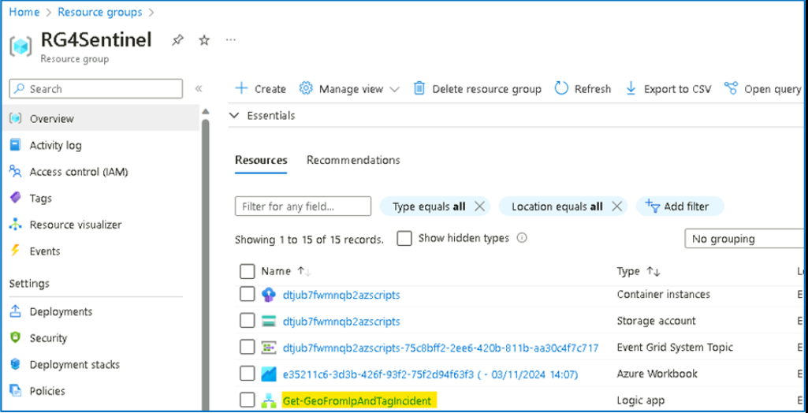

1. Click on the last playbook run.

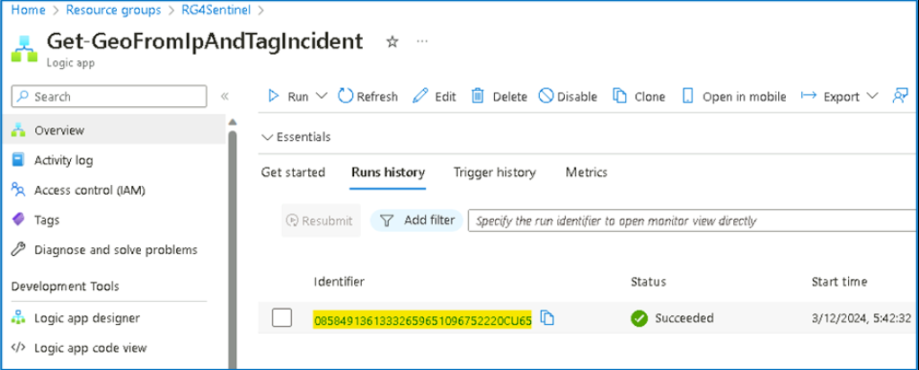

1. You will be able to review the execution steps.

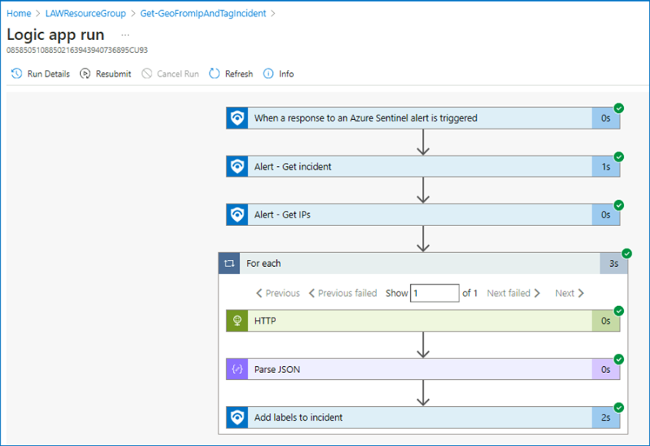

1. From the Azure portal go to **Home** > **Microsoft Sentinel** > **SwrkXXXXXXX**. In the left navigation click on **Workbooks**.

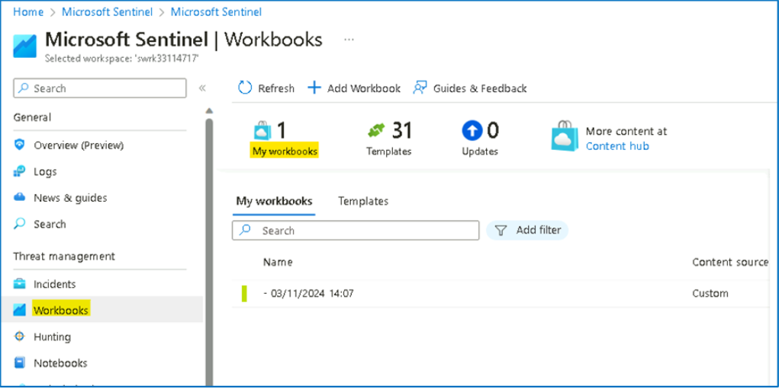

1. In the right page press panel select **View saved workbook**.

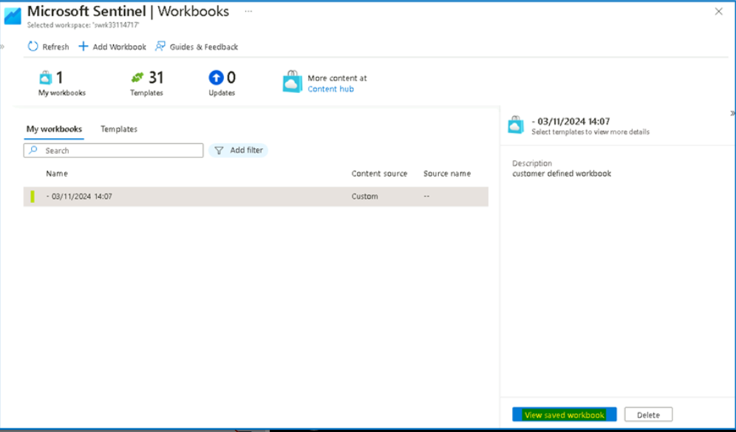

1. It will open **Investigation Insights - <date>**, the saved Workbook.

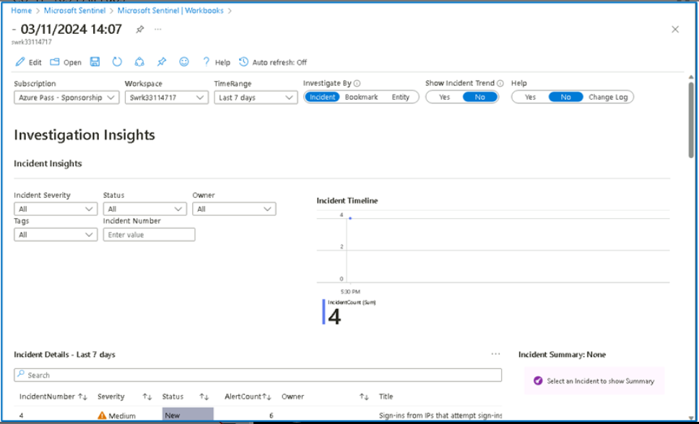

1. Validate that in the properties selector, your workspace is set to **SwrkXXXXXXX** and the subscription is set to **Azure Pass - Sponsorship**.

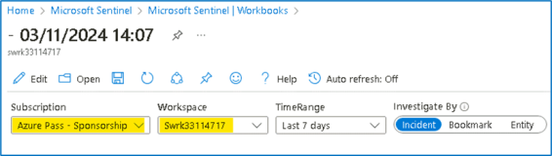

1. As the subject of the investigation is the suspicious IP, we want to see all the activity done by this IP. So in the properties selector, switch on the **investigate by** to **Entity**.

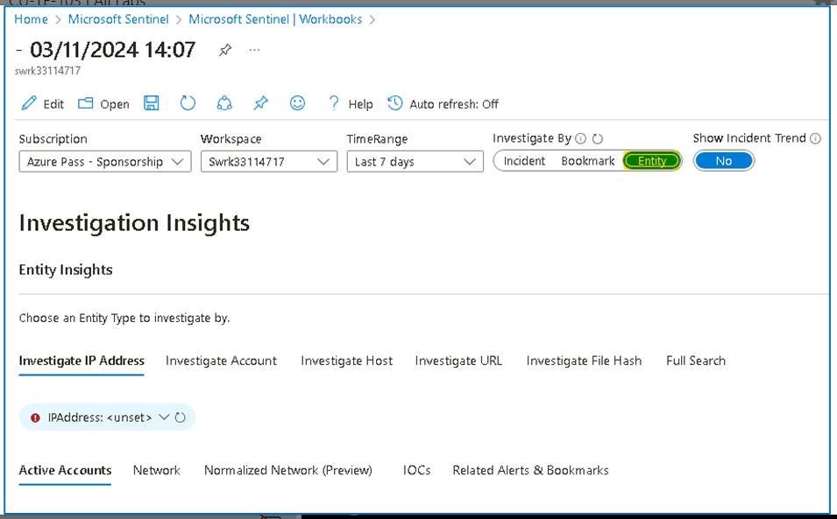

1. In the **Investigate IP Address** Tab, add the suspicious IP - [**175.45.176.99**](urn:gd:lg:a:send-vm-keys) that we noted in one of the previous steps.

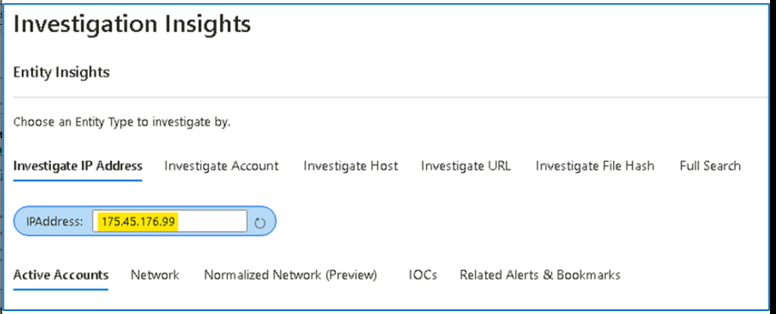

1. Under the Activity Detail you will be able to review successful logins from this IP with the user **Adele**, and also some failed logins to disabled accounts, ensure to set the time span to Last 7 Days.

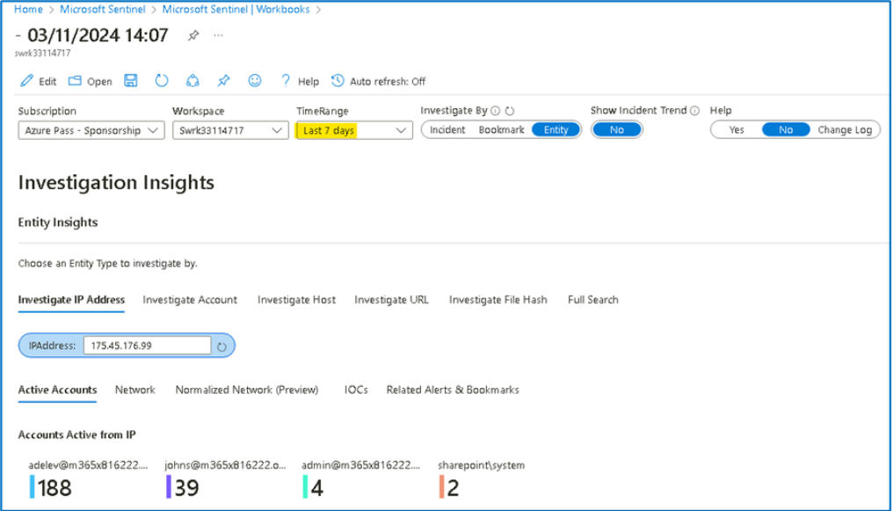

1. Scroll down and click on **Details** column [**twice**] to arrange the activity logs in an order to easily find the failed logins to disabled account.

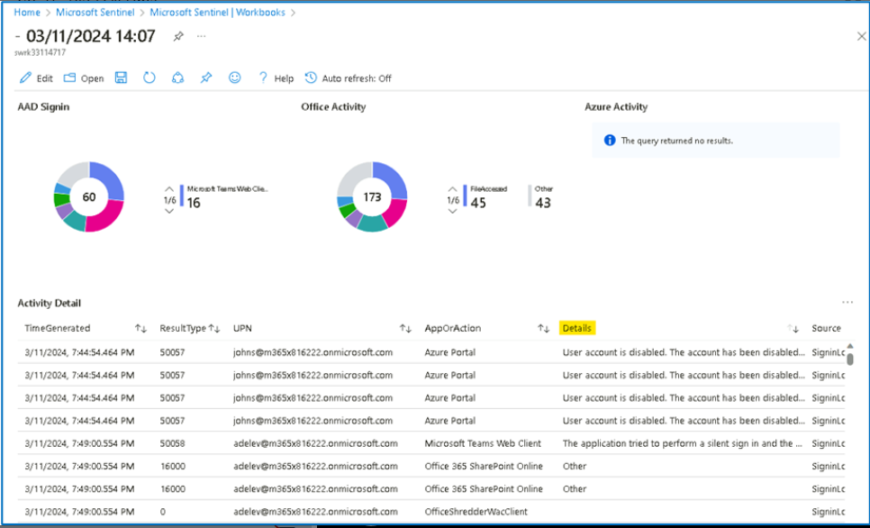

Suppose the User [**adelev@m365x816222.onmicrosoft.com**](urn:gd:lg:a:send-vm-keys) is validated in the internal HR system. From the information we collected, it seems that **Adele** is part of the security Red team, and this suspicious activity is the part of an exercise they conducted. Hence, the SOC manager ask us to add this IP to the whitelisting IP's, so that the system will not trigger incident on it any more. To do this we will follow the following steps.

1. From the Investigation insights page, click on the **Microsoft Sentinel** link.

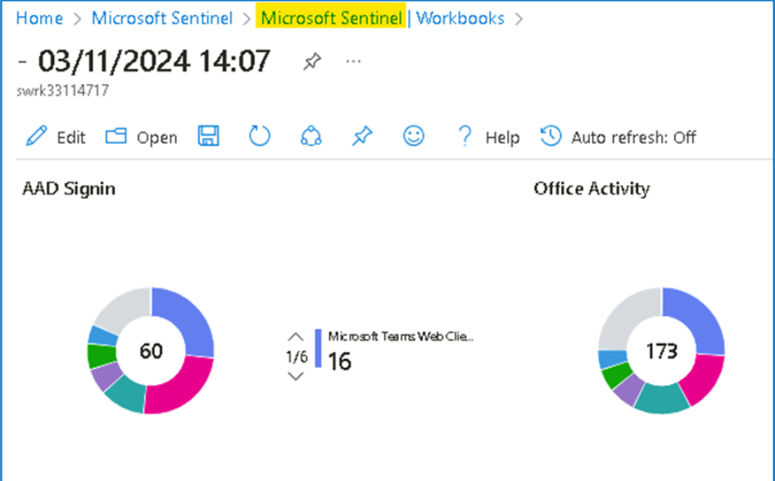

1. From the navigation select **Incidents**, then click **on Sign-ins from IPs that attempt sign-ins to disabled accounts**. Click on **View full details**.

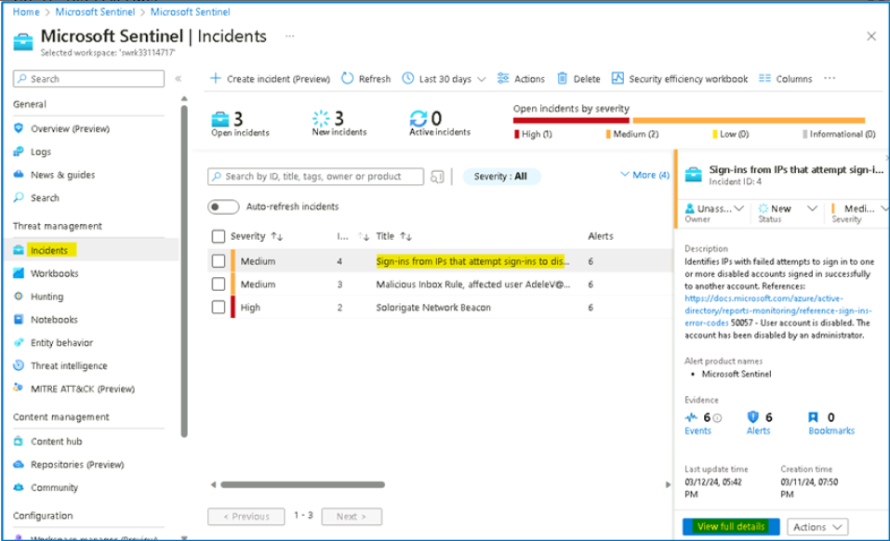

1. On the main incident page, select the relevant incident and press **Incident** **Actions > Create automation Rule**.

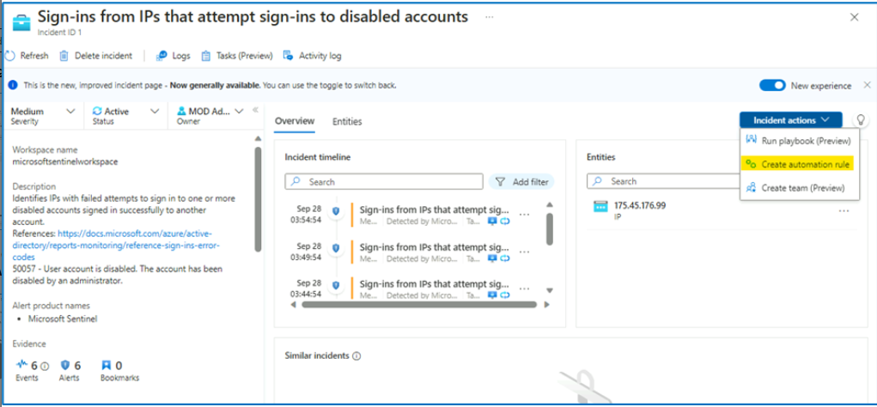

1. In the expanded screen, we will see all the incident identifiers (the IP, and the specific Analytics rule). Set the rule expiration after two days and press **Apply**.

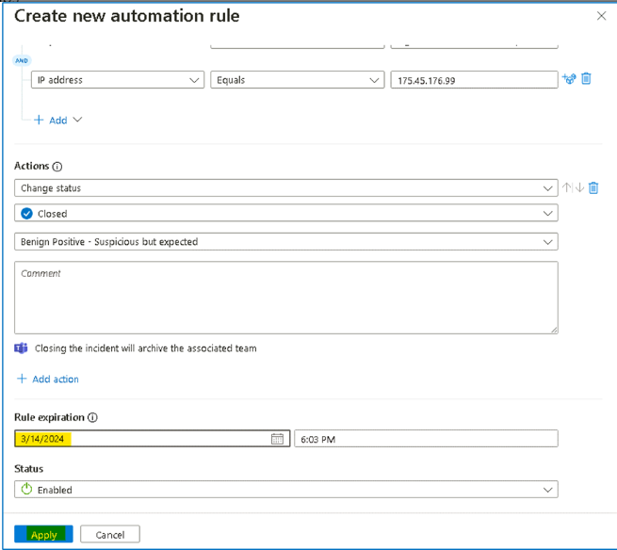

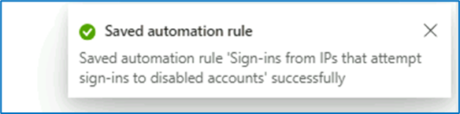

1. On the main Incident page, under status, select **Close** from the drop down, classify the Incident as **Benign Positive - Suspicious but expected** and select **Apply**.

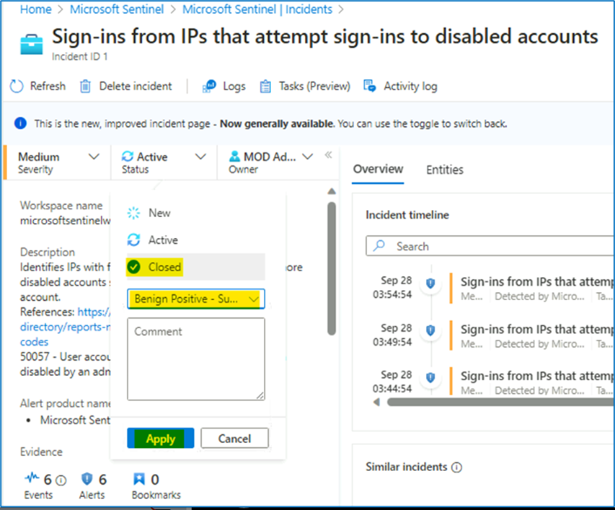

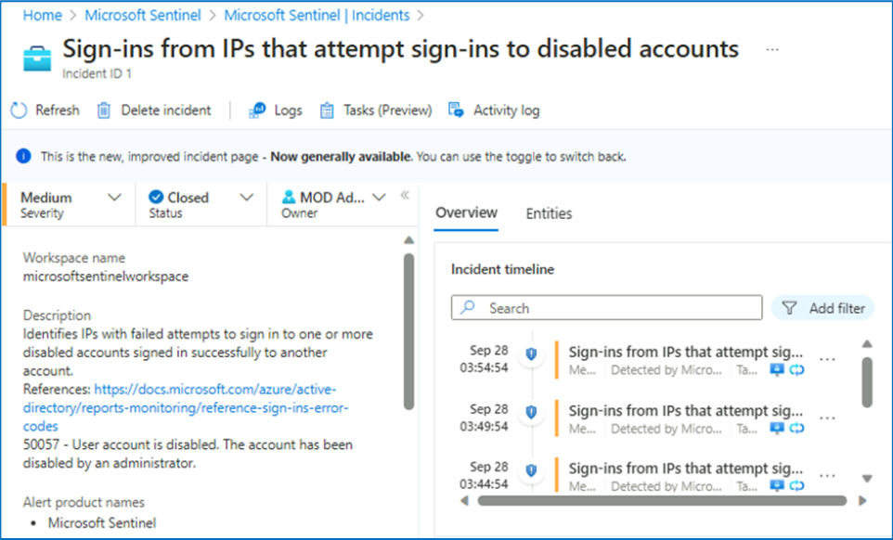

## Task 7 - Handling "Solorigate Network Beacon" incident

1. On the Azure Portal [**http://portal.azure.com**](urn:gd:lg:a:send-vm-keys), search for [**Microsoft Sentinel**](urn:gd:lg:a:send-vm-keys) and click on **Microsoft Sentinel**.

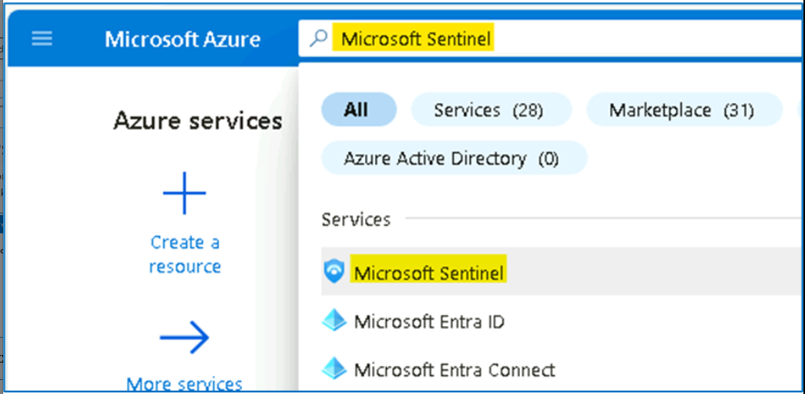

1. Select **SwrkXXXXXXX**.

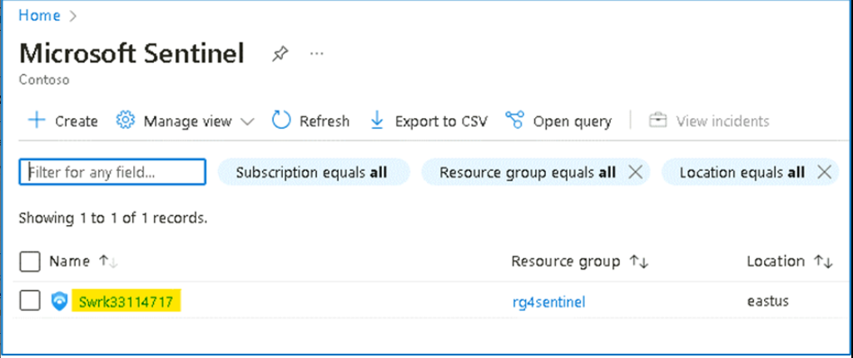

1. Now click on **Incidents** to open the incidents page. This page will show by default all the open incidents in the last 24hr. Set the time span for **Last 30 days** from the top bar.

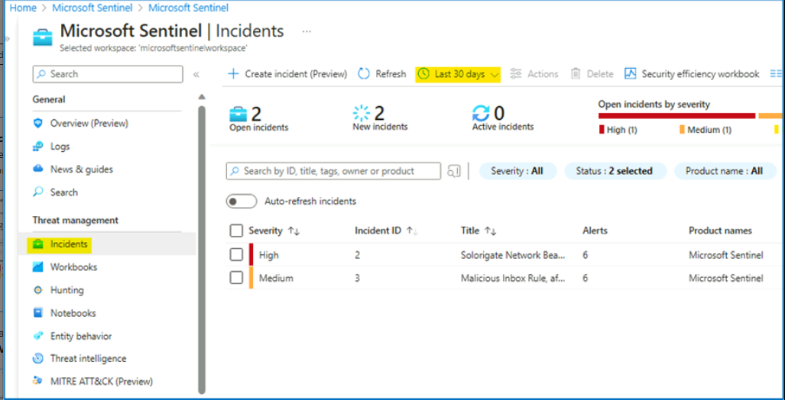

1. From the list of active incidents, select "**Solorigate Network Beacon**" incident. Select **View full details**.

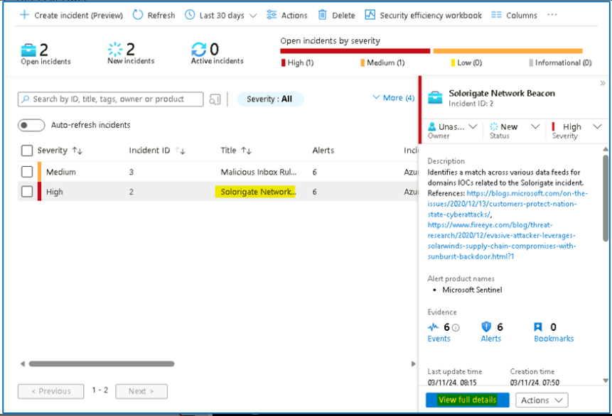

1. Under **Owner**, select **Assign to me** from the dropdown, to assign the incident to yourself and click **Apply**.

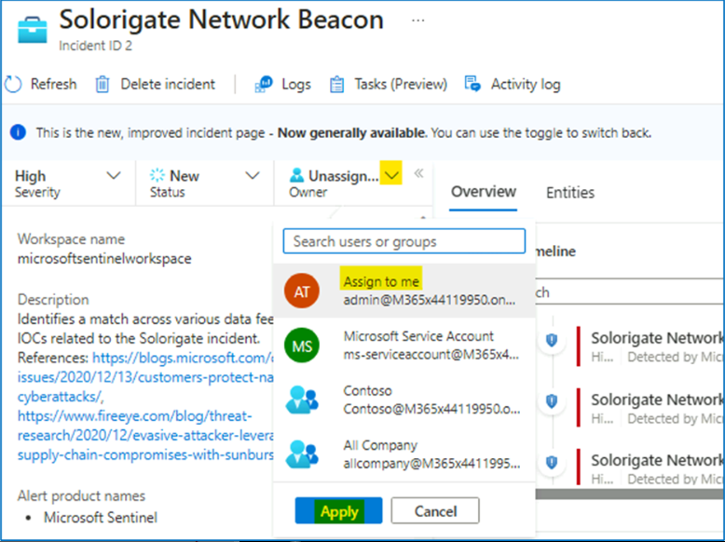

1. Read the description of the incident. As you can see, one of the domain IOCs related to **Solorigate** attack has been found. In this case, domain **avsvmcloud.com** is involved.

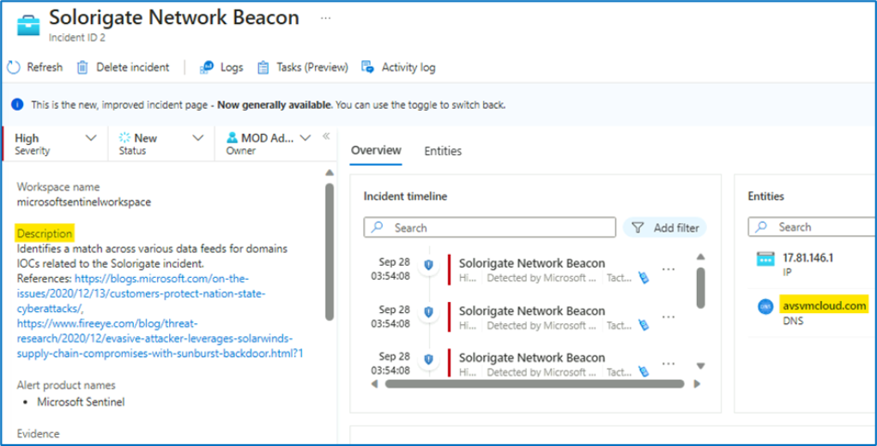

1. From the right side of the screen select **Incident actions** > **Run playbook (Preview)**.

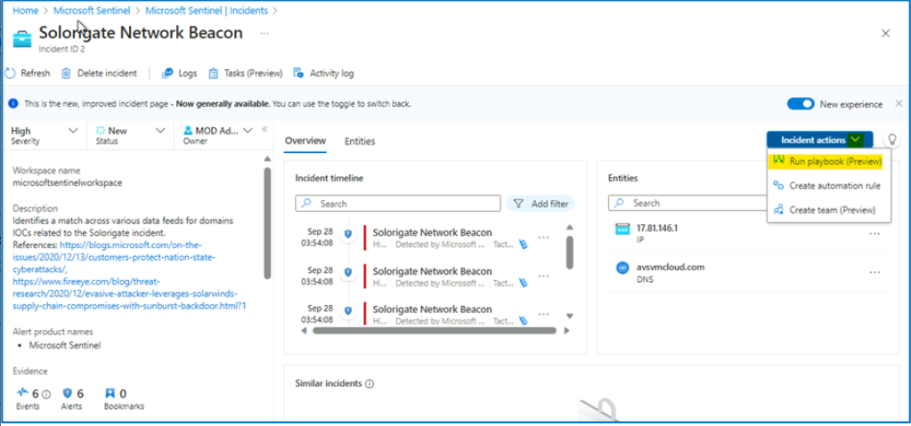

1. Click on the **customplaybook**

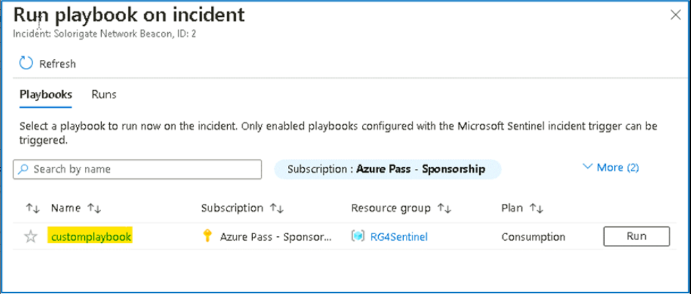

1. Then click on the **Run** drop down and select **Run**

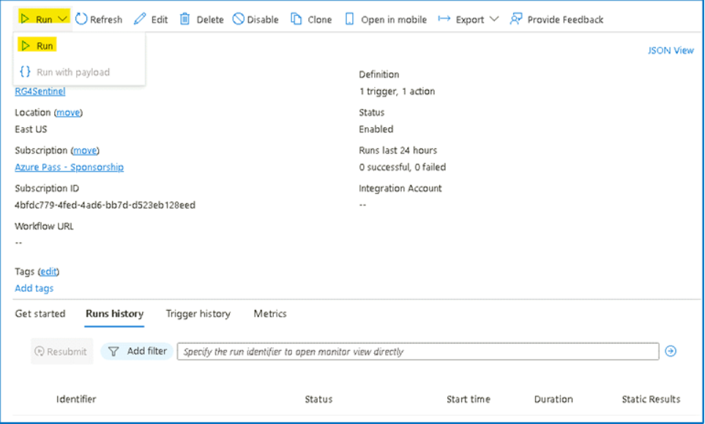

1. You will be able to see the notification that the **Successfully checked the trigger.**

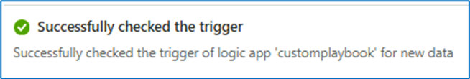

## Task 8 - Hunting for more evidence

As a next step, you would like to identify the hosts that might have been compromised. As part of your research, you find the following guidance from Microsoft. In this article, you can find a query that will do a SolarWinds inventory check query. We will use this query to find any other affected hosts.

1. On the Azure Portal [**http://portal.azure.com**](urn:gd:lg:a:send-vm-keys), search for [**Microsoft Sentinel**](urn:gd:lg:a:send-vm-keys) and click on **Microsoft Sentinel**.

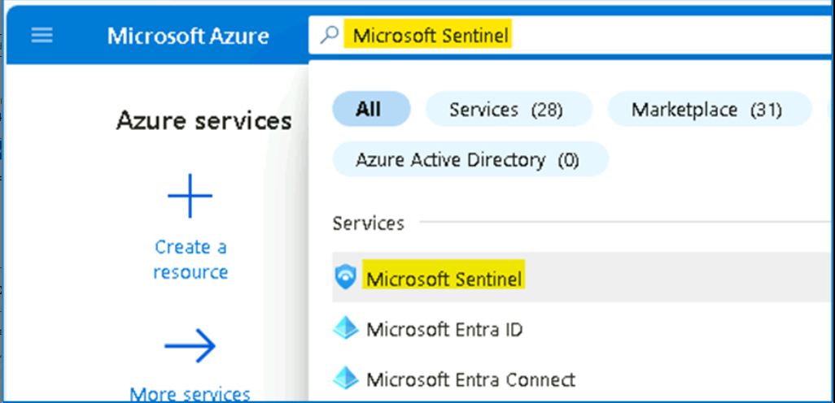

1. Select **SwrkXXXXXXX**.

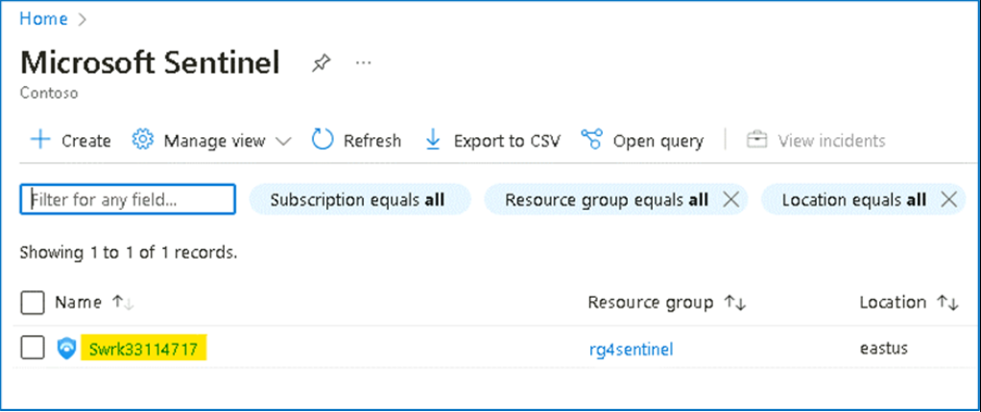

1. Now click on **Hunting** and then select the **Queries** tab.

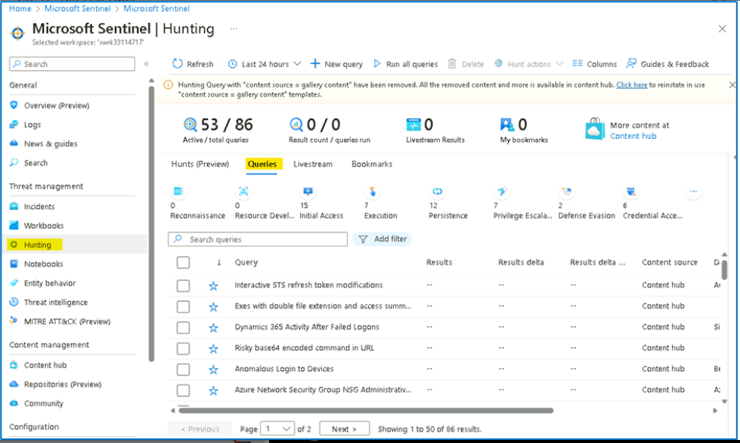

1. In the search box, type "**[solorigate](urn:gd:lg:a:send-vm-keys" \o "Paste text into VM)**". Select **Solorigate Inventory check** query.

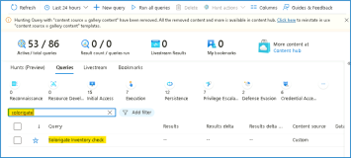

1. Click on **Run Query**.

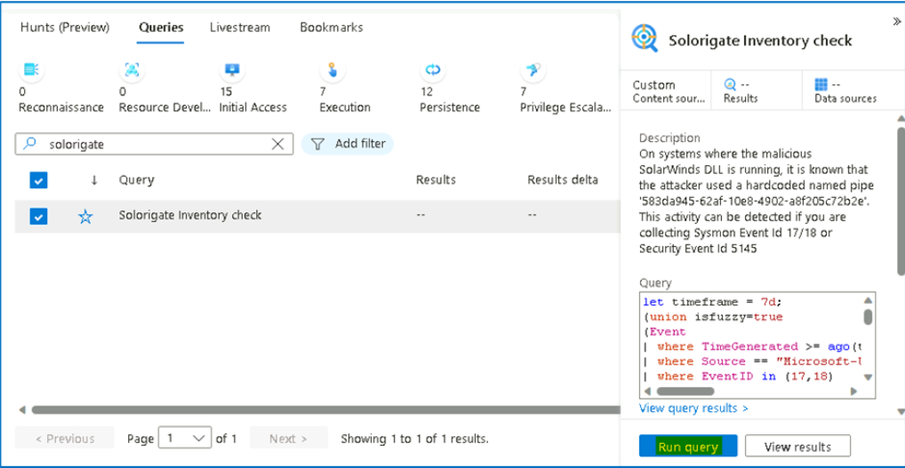

1. You should see a total of three results. Click on the **3 Results** or **View Results**.

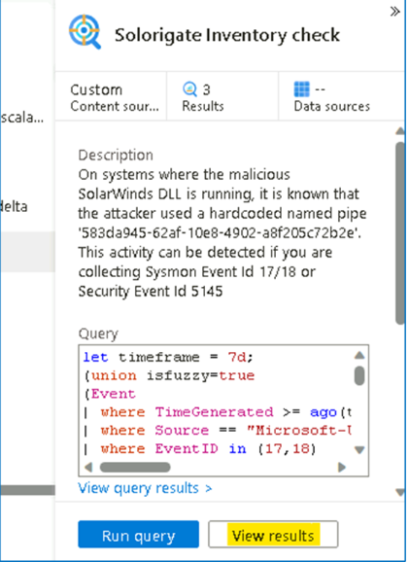

1. As you can see, under **AccountCustomEntity**, there are two additional computers where the malicious DLL and named pipe has been found. Bookmark those additional records, by selecting them and then clicking on **Add bookmark**.

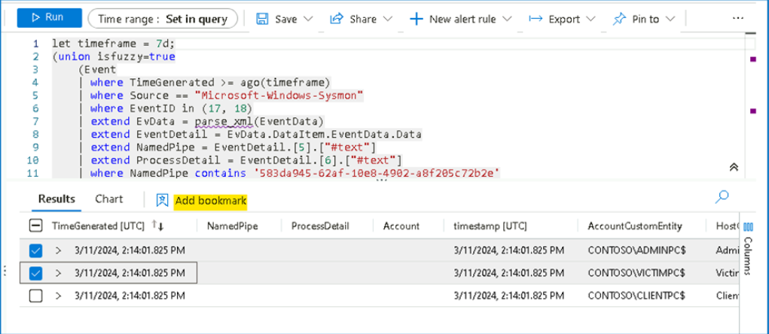

1. In the flying pane that appears, click on **Create** to create the bookmarks. As you can see entity mapping to already done for you.

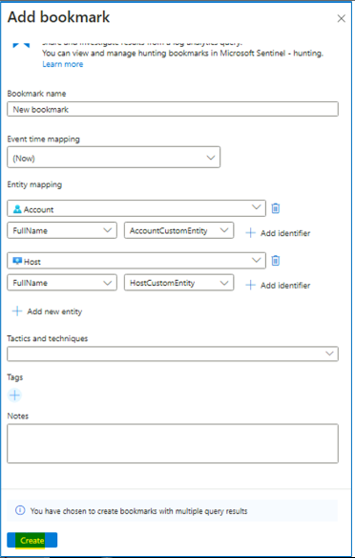

1. Wait until the operation finishes and close the log search using the ✖ at the top right corner.

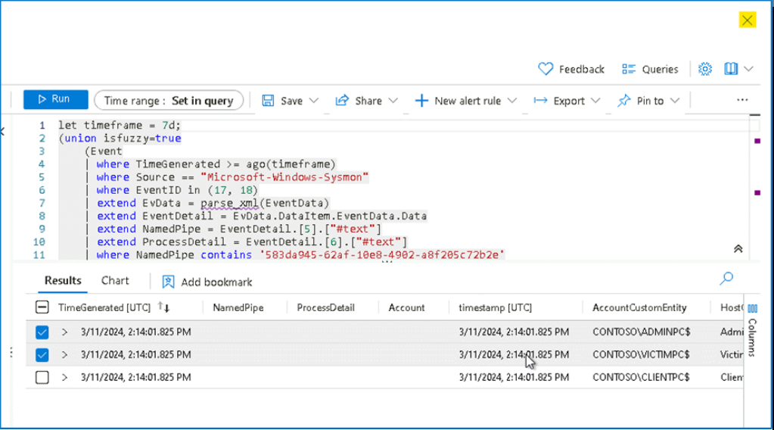

1. Click on **Bookmarks** tab inside **Hunting** menu and click **Refresh**, where you should see your two new bookmarks created.

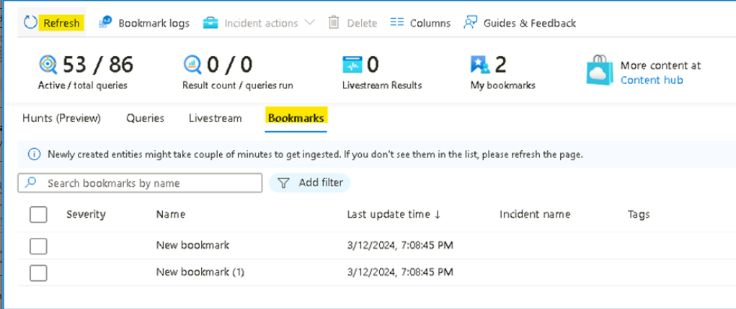

1. Select both of them and click on **Incident actions** at the top and then **Add to existing incident**.

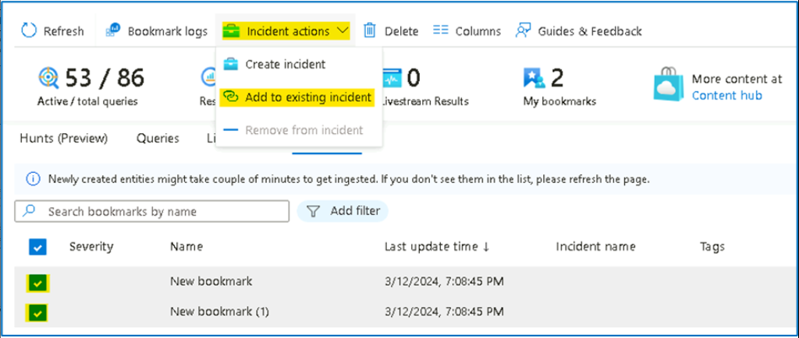

1. From the list, pick the **Solorigate incident** that is assigned to you, and click **Add**.

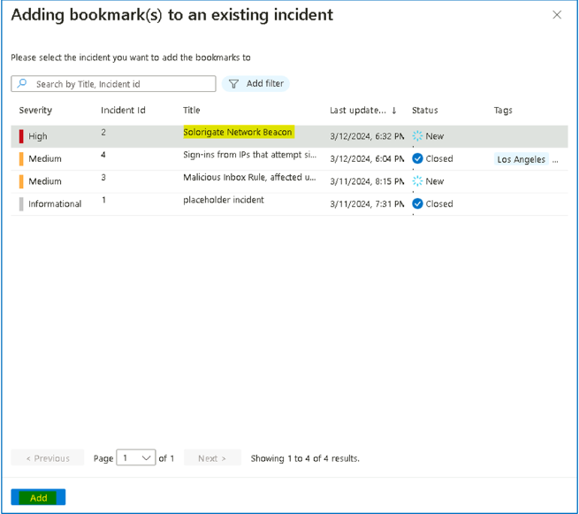

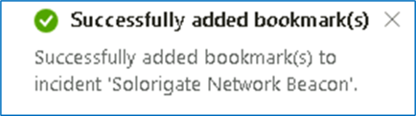

1. At this point you can ask the Operations team to isolate the hosts affected by this incident. Continue to the next task without closing the window.

Task 9 - Adding IOC to Threat Intelligence

Now, we will add the IP address related to the incident to our list of IOCs, so we can capture any new occurrences of this IOC in our logs.

1. Click on **Incidents** under Threat management.

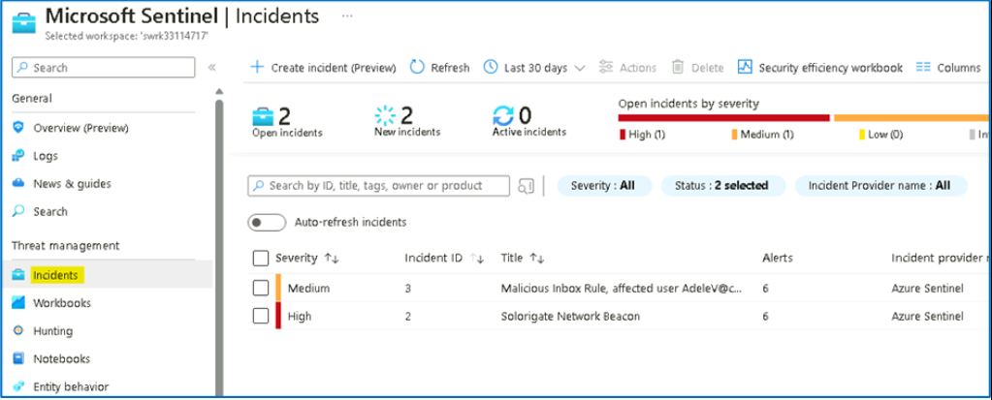

1. Select the **Solorigate incident** and click on View full details.

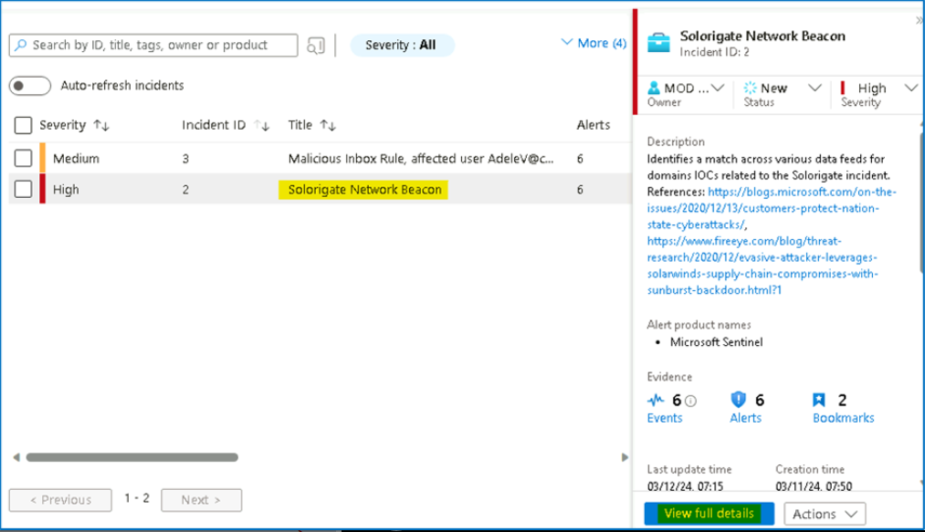

1. Note down the **IP address** entity involved. Notice that you have now more computer entities available (the ones coming from the bookmarks).

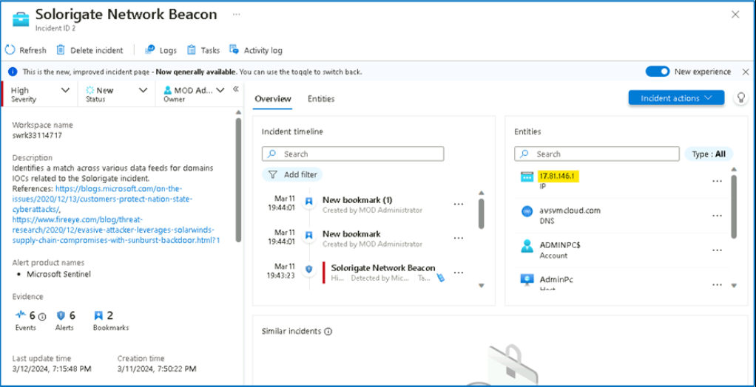

1. Click on **Threat Intelligence** under Threat management and click **Add new**

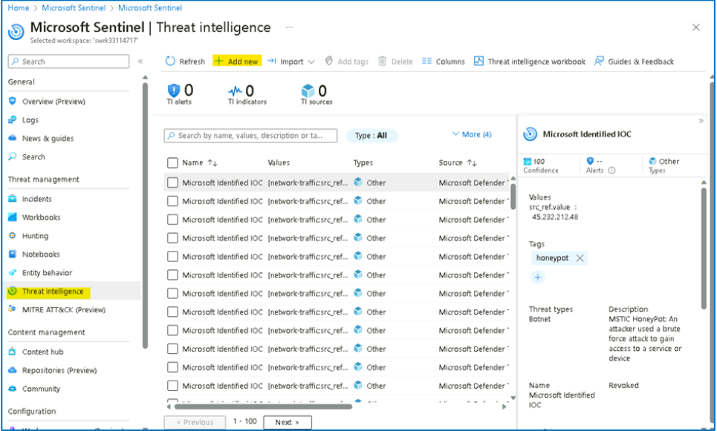

1. Enter the following details in the **New indicator** dialog, with **Valid from** being today's date and **Valid until** being two months after. Then click **Apply**.
   * Types -- **ipv4-addr**
   * Ipv4 address -- **The address we copied in the previous step of this exercise.**
   * Name -- [**Threat1**](urn:gd:lg:a:send-vm-keys)

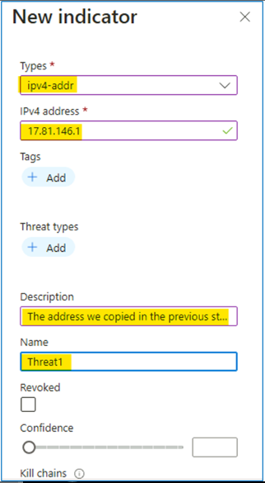

1. Enter the **Valid from** and **Valid until** dates and then click on **Apply**

